**VARIATIONS IN VISFATIN LEVELS IN HYPERTENSIVE AND NORMOTENSIVE MENOPAUSAL WOMEN IN BENIN CITY, NIGERIA**

**\*Osayande S.I, Ugwu A.C, Omorogiuwa A. Agoreyo F.O, Osayande O.E. and Onuyoh-Adaitire B.**

Department of Physiology, School of Basic Medical Sciences, College of Medical Sciences

University of Benin

|  |
| --- |
|  |

**ABSTRACT:** *Visfatin is a hormone produced in visceral adipose tissues. It is a protein present in several mammals, and encoded by the NAMPT gene within humans. The aim of this study was to establish a possible relationship between visfatin and hypertension and to delineate a possible mechanism of action for visfatin and reactive oxygen species. The study was carried out in the department of physiology, university of Benin, Nigeria. 150 women were enrolled. Results show a significant increase in visfatin levels of perimenopausal normotensives than in perimenopausal hypertensives*.

**KEY WORDS:** visfatin, perimenopausal, normotensive, hypertensive

|  |
| --- |
|  |

**INTRODUCTION**

**Hypertension and Menopause**

The global burden of hypertension is rapidly increasing, and the Africa seems to be among the most affected region in the world. The prevalence of hypertension in Nigeria forms a substantial portion of the total burden in Africa because of the large population of the country which is currently estimated to be over 170 million. According to a research carried out by Adeloye *et al.,* in 2014, the prevalence of hypertension is high among the Nigerian population, ranging from 28.9% with a prevalence of 29.5% among men, and 25.0% among women. Hypertension is more common in postmenopausal females than males. As they move from perimenopausal to postmenopausal state, a normal protection from cardiovascular (CV) disease is withdrawn and control of hypertension also becomes tougher despite being more sincere in blood pressure (BP) monitoring and treatment (Ong *et al.,* 2008). This rise in blood pressure denotes aging in both males and females, with 41% of postmenopausal women being hypertensive. Globally, 25% of females become hypertensive at menopause and in the USA; over 75% of women over 60years of age are hypertensive (Kearney *et al.,* 2005).

One mechanism by which BP may be increased in aging postmenopausal women is activation of the renin-angiotensin system (RAS). Postmenopausal women exhibit increase in plasma renin activity (Schunkert, *et al.,* 1992), suggesting activation of the RAS. In addition, there may be a genetic component of the RAS that contributes to postmenopausal hypertension, as certain renin gene polymorphisms are associated with hypertension in women aged 40 to 70 years, but not in men (Mansego, *et al.,* 2008).

**VISFATIN**

Visfatin was recently identified as an adipocyte hormone preferentially produced in visceral adipose tissue. It is a protein present in several mammals, and encoded by the NAMPT gene within humans. It is expressed to a high degree in visceral fat, and also known as nicotinamide phosphoribosyltransferase, (NAMPT). Adipokines are inflamatory mediators such as complement factors B, C3, and D, haptoglobin, hepatocyte growth factor, adiponectin, prostaglandin E2, interleukin (IL)-1, IL-6, IL-8, IL-10, leukemia inhibitory factor, macrophage migration inhibitory factor, tumor necrosis factor (TNF), e. t. c (Hassan *et al,* 2012). The concentration of these adipokines may be altered or unregulated in many metabolic disorders, including obesity, type 2 diabetes, and sepsis, cardiovascular disorders, such as hypertension, atherosclerosis and other cardiovasculo-metabolic disorders (Fain *et al.*, 2004; Dahl *et al.,* 2007, Lee *et al.,* 2009, Belo *et al.,* 2013).

The first form of visfatin to be discovered in 1994 was PBEF. At the time, a protein, with cytokine-like activity, was initially uncovered from the bone marrow cDNA library (Samal *et al.,* 1994). It was then named pre-B-cell colony-enhancing factor (PBEF), as a result of its enhancing role in murine pre-B-cell colony formation from early B lineage precursor cells (Samal *et al.,* 1994). In 2001, a gene, with a similar sequence to PBEF, known as nadV, was discovered to permit NAD-independent growth of Gram-negative bacteria such as Haemophilus influenza and actinobacillus (Martin *et. al.,* 2001). This shed light on a possible underlying role of PBEF in nicotinamide adenine dinucleotide (NAD) biosynthesis. In 2002, PBEF was seen to be a protein with enzymatic properties capable of catalyzing the synthesis of nicotinamide mononucleotide (NMN), an intermediate of NADbiosynthesis, from nicotinamide (NAM) and 5-phosphoribosyl-1-pyrophosphate (Rongvaux *et al.,* 2002). As a result, PBEF was renamed nicotinamide phosphoribosyltransferase (NAMPT). NAMPT is a dimeric type 2 phosphoribosyltransferase that plays a very significant role in the biosynthesis of NAD (Wang *et. al.,* 2006). In 2005, a study revealed that NAMPT or PBEF is a protein that is secreted solely by visceral fat; hence, it was called visfatin meaning visceral fat-specific adipokine (Fukuhara *et. al.,* 2005). The terms visfatin, PBEF, and NAMPT are currently used interchangeably. (Hassan *et al.,* 2012).

In cardiovascular diseases, visfatin was first proposed as a clinical marker of artherosclerosis, endothelial dysfunction and vascular damage, with a potential prognostic value. However, apart from being a surrogate clinical marker, visfatin/Nampt is an active player that promotes vascular inflammation, and atherosclerosis. Visfatin/Nampt has significant effects on cytokine and chemokine secretion, macrophage survival, leukocyte recruitment by endothelial cells, vascular smooth muscle inflammation and plaque destabilization making this adipokine an active factor in the development and progression of atherosclerosis. (Fain *et al.*, 2004; Dahl *et al.,* 2007, Lee *et al.,* 2009, Belo *et al.,* 2013).

**OXIDATIVE STRESS AND HYPERTENSION.**

In humans, oxidative stress is well known to be involved in the pathogenesis of lifestyle-related conditions including atherosclerosis, hypertension, diabetes mellitus, ischemic diseases, and malignancies. (Yoshikawa and Naito, 2002). Oxidative damage has been identified even in early stages of these diseases, indicating that their aetiologies are linked to free radicals. Oxidative stress has been described as harmful because of the way oxygen free radicals attack biological molecules such as lipids, proteins and DNA (Czerska *et al.,* 2015). Hypertension is considered to be the most important risk factor in the development of cardiovascular disease. An increasing body of evidence suggests that oxidative stress, which results in an excessive generation of reactive oxygen species (ROS), has a key role in the pathogenesis of hypertension (González *et al.,* 2014).

**VISFATIN AND HYPERTENSION**

Visfatin is an endocrine, autocrine as well as paracrine peptide with several functions. Apart from the role it plays in the nicotinamide adenine dinucleotide biosynthesis process, it catalyzes the nicotinamide with 5-phosphoribosyl-1-pyrophosphate to yield nicotinamide mononucleotide. It also plays a role in the biosynthesis of nicotinamide dinucleotide. Further functions also include the enhancement of cell proliferation, the process by which the number of cells is increased and the balance kept by mixture of cell death and differentiation. This is particular to the enhancement of vascular smooth muscle cell maturation and inhibition of neutrophil apoptosis. It also has a function within the hypoglycemic effect, where it causes insulin within the blood to quickly drop, by lowering blood glucose and improving insulin sensitivity as an insulin receptor activator. It is because of this latter function that it has become known primarily for its relationship with type 2 diabetes, potentially as a genetic marker to help identify those who are predisposed to the condition (Adeghate, 2008).

In 2015, Xia *et.* al carried out a study on the Association between serum leptin, adiponectin, visfatin, obesity and hypertension in females. They discovered in their research that adiponectin and visfatin levels are correlated with obesity and blood pressure in females. They went further to state that both adiponectin and visfatin may play a major role in the development of hypertension in female obesity. Another study on the relationship between serum levels of visfatin and hypertension carried out by Lu, *et* al, in 2016, showed that there is a positive relationship between serum visfatin levels and the development of hypertension. In their research, they stated that the level of visfatin is positively correlated with systolic blood pressure. Contrarily, Dogru *et* al, in 2007 carried out a research on plasma visfatin levels in young male patients with uncomplicated and newly diagnosed hypertension. They suggested in their study that plasma visfatin levels has no association with blood pressure, insulin sensitivity and inflammation in young hypertensive patients, indicating that dysregulation of visfatin may not be a part of pathogenesis of new onset hypertension. Also, Kocelak *et al.,* in 2015 carried out a study on plasma visfatin /nicotinamide phosphoribosyl transferase levels in hypertensive elderly. Their study showed that the presence of hypertension is not linked with plasma visfatin levels in elderly subjects. They, however, stated in their study that a plasma visfatin/NAMPT concentration is positively correlated with inflammation and insulin resistance.

**MATERIALS AND METHOD**

**MATERIALS:**

* Bicycle ergometer
* Sphygmomanometer
* Standiometer scale
* Digital weighing scale
* ELISA kit
* Spectrophotometer
* Centrifuge
* Test tubes/rack
* Timer
* Cotton wool
* Plain sample bottles
* heparinized Sample bottles
* Questionnaires
* 70% alcohol
* Syringes and needles
* Hand Gloves
* Tourniquet

The study was carried out in the physiology laboratory of the Department of Physiology, University of Benin, Benin City. All Subjects were recruited from different areas in Benin City, some hypertensive subjects were gotten from Department of Family Medicine, University of Benin Teaching Hospital (UBTH), St. Philomena Hospital, Benin City, Stella Obasanjo Hospital, Benin, and Central Hospital, Benin.

**SAMPLE SIZE:**

A total of 150 subjects were used for the study. This was derived using the sample size formula by Naing *et al.,* 2006:

n= $\frac{Z^{2}P (1-P)}{d^{2}}$ = $\frac{{1.96}^{2}X0.1(1-0.1)}{{0.05}^{2}}$

n= $\frac{0.38416X0.9}{0.0025}$ = $\frac{0.345744}{0.0025}$ = 138.3 approx. 150

Where n= sample size,

Z = statistics for a level of confidence (1.96)

P = prevalence = 0.5 (sample size for an unknown population) (Rose, 2015)

d = precision or tolerable error of margin (0.05)

**EXCLUSION CRITERIA**

Questionnaires were used to access those that are qualified to participate in the study. Exclusion criteria included:

* Patients with extreme cases of hypertension (with systolic blood pressure greater than 200mmhg).
* Diabetic patients
* Pregnant women.

**INCLUSION CRITERIA**

* Hypertensive (HTN) and normotensive (NT) premenopausal women
* Hypertensive (HTN) and normotensive (NT) perimenopausal women
* Hypertensive (HTN) and Normotensive (NT) perimenopausal women

In order to establish the presence of hypertension, blood pressure for each subject was consistently measured for a period of 21 days. Subjects with persistently high blood pressure (systolic ≥ 140mmhg and diastolic ≥ 90mmhg) were considered hypertensive.

**METHODOLOGY**

The subjects were divided into two groups: Non-hypertensive perimenopausal women (periM) and hypertensive perimenopausal women (periM).

**periM group**

This group was made up of women between the ages of 45 and 55. The Questionaires administered were used to ascertain that they fall within the menopause transition stage of life. Furthermore, subjects were divided into groups A and B. Group A was the hypertensive perimenopausal women, and group B included non-hypertensive perimenopausal women.

Prior to the study, verbal consent was obtained from each subject and permission to make use of human subjects was sought from the ethical committee of the University of Benin Teaching Hospital (UBTH) and Ministry of Health, Edo State.

On arrival at the laboratory the volunteered subjects were allowed to acclimatize for a period of 30 minutes before the commencement of the experiment. Subsequently, their anthropometric data and blood pressures were obtained. Blood pressure for each subject was measured manually using a mercury sphygmomanometer. Studies commenced on each subject about an hour after their last meal. After the anthropometric data and blood pressure recording was done, blood, urine, saliva and sweat were collected from each subject.

**SAMPLE COLLECTION**

**BLOOD**

10ml of Blood was collected from the antecubital vein of each subject (venipuncture). Firstly, a tourniquet was applied 3-4inches above the selected site. The area was then disinfected with methylated spirit and allowed to air dry for about 30seconds. To get veins more palpable and prominent, each subject was asked to make a fist. Blood was then collected by carefully inserting the syringe into the vessel at an angle of 15-30 degrees. Blood sample for each subject was then dispensed into lithium heparin (5mls) and plain sample bottles(5mls) respectively (Dayyal, 2018).

**URINE**

Urine was collected between 7am and 10am in a private toilet facility. Each subject was asked to pass urine into a universal sample bottle. Before the collection process, subjects were advised to wipe the urethral meatus from front to back to prevent contamination. In order to get midstream urine, subjects were asked to allow the first portion of urine flow out before allowing about 50mls flow into the bottle (Hamad, 2018).

**SALIVA**

4mls of saliva was collected into plain sample bottles between 7am and 10am before meal. Each subject was asked to rinse the mouth twice with distilled water for 1min, after which they were allowed to swallow some distilled water. Five minutes after the oral rinse, each subject was asked to pass saliva into the plain sample bottle provided (Henson and Wong, 2010).

**SWEAT**

Prior to sweat collection bicycle ergometer was calibrated according to the method recommended by Clark and Greenleaf in 1971.

Sweat for each subject was collected into an air-tight plain sample bottle. In order to collect sweat effectively, subjects were made to undergo exercise using the bicycle ergometer for a period of 15 minutes at a speed of 60rpm per hour. Sweat was collected from a 120cm2 demarcated circular area on the face and neck using the Ugwu and Oyebola sweat suction apparatus (1996). To ensure optimum privacy, sweat collection was done in the sweat chamber located in the department of physiology Laboratory, University of Benin, Benin City.

**SAMPLES ANALYSIS**

Visfatin samples were stored at the chemical pathology laboratory, university of Benin Teaching Hospital (UBTH). Analysis for visfatin levels was also carried out in the chemical pathology laboratory of the University of Benin teaching hospital (UBTH) Benin. Visfatin was analyzed using ELISA kit purchased from E-lab Science, U.S.A. mRNA analysis for visfatin was carried out using a Zymo Quick-RNA Miniprep Kit (Zymo Research USA). Analysis for oxidative markers was carried out immediately after sample collection at the biochemistry Department, University of Benin, Nigeria.

**STATISTICAL ANALYSIS**

All data are presented as mean ± standard error of mean (SEM). Statistical analysis was done using graphpad prism 8.1. P values less than 0.05 (P<0.05) was considered statistically significant. Comparisons were done using two-way Ansalysis of Variance (ANOVA).

**RESULTS**

**Table 1:** showing the significant difference (p<0.05) in the ages, systolic blood pressure (SBP) diastolic blood pressure (DBP) and body mass index (BMI) of hypertensive (HTN) and Normotensive (NT) perimenopausal (periM) women.

**FIGURE 1:** showing that serum is the most viable sample for evaluating visfatin levels in humans.

**FIGURE 2:** showing correlation between serum visfatin level and systolic blood pressure in normotensive women.

**FIGURE 3:** showing correlation between serum visfatin level and systolic blood pressure in hypertensive women.

**Figure 4:** plasma Superoxide dismutase concentration in premenopausal, perimenopausal and postmenopausal hypertensive and normotensive women

**FIGURE 5:** correlation between serum visfatin and catalase in periM.

**FIGURE 6:** mRNA expression of visfatin

**Figure 7:** Possible mechanism for visfatin synthesis and its relationship with oxidative stress.

**TABLE 1: Anthropometric data**

|  |  |  |  |
| --- | --- | --- | --- |
| Parameters |  | Peri-menopausal | Post-menopausal |
| SBP | Normotensive | 121.8 ± 2.61 | 125.6 ± 1.92 |
| Hypertensive | 152.8 ± 0.85 | 157.4 ± 1.82 |
| P-values | *P < 0.05* | *P < 0.05* |
| DBP | Normotensive | 76.80 ± 1.50 | 79.40 ± 2.05 |
| Hypertensive | 100.2 ± 1.10 | 101.2 ± 1.05 |
| P-values | *P < 0.05* | *P < 0.05* |
| BMI | Normotensive | 36.04 ± 0.71 | 31.99 ± 1.04 |
| Hypertensive | 36.18 ± 1.21 | 35.22 ± 1.04 |
| P-values | *P > 0.05* | *P < 0.05* |
| AGE | Normotensive | 45.80 ± 0.41 | 56.24 ± 0.51 |
| Hypertensive | 47.40 ± 0.55 | 60.16 ± 0.67 |
| P-values | *P < 0.05* | *P < 0.05* |



**FIGURE 1: visfatin levels in different body fluids**



**FIGURE 2: correlation between visfatin and systolic blood pressure in normotensive (NT) preM, periM and postM subjects.**



**FIGURE 3: correlation between serum visfatin and systolic blood pressure in hypertensive (HTN) subjects**



**Figure 4: plasma Superoxide dismutase concentration in premenopausal, perimenopausal and postmenopausal hypertensive and normotensive women**



**Figure 5**: graph showed the relationship between visfatin level and catalase activity in the serum of hypertensive individuals.

The showed that there was a positive correlation between visfatin and catalase activity.

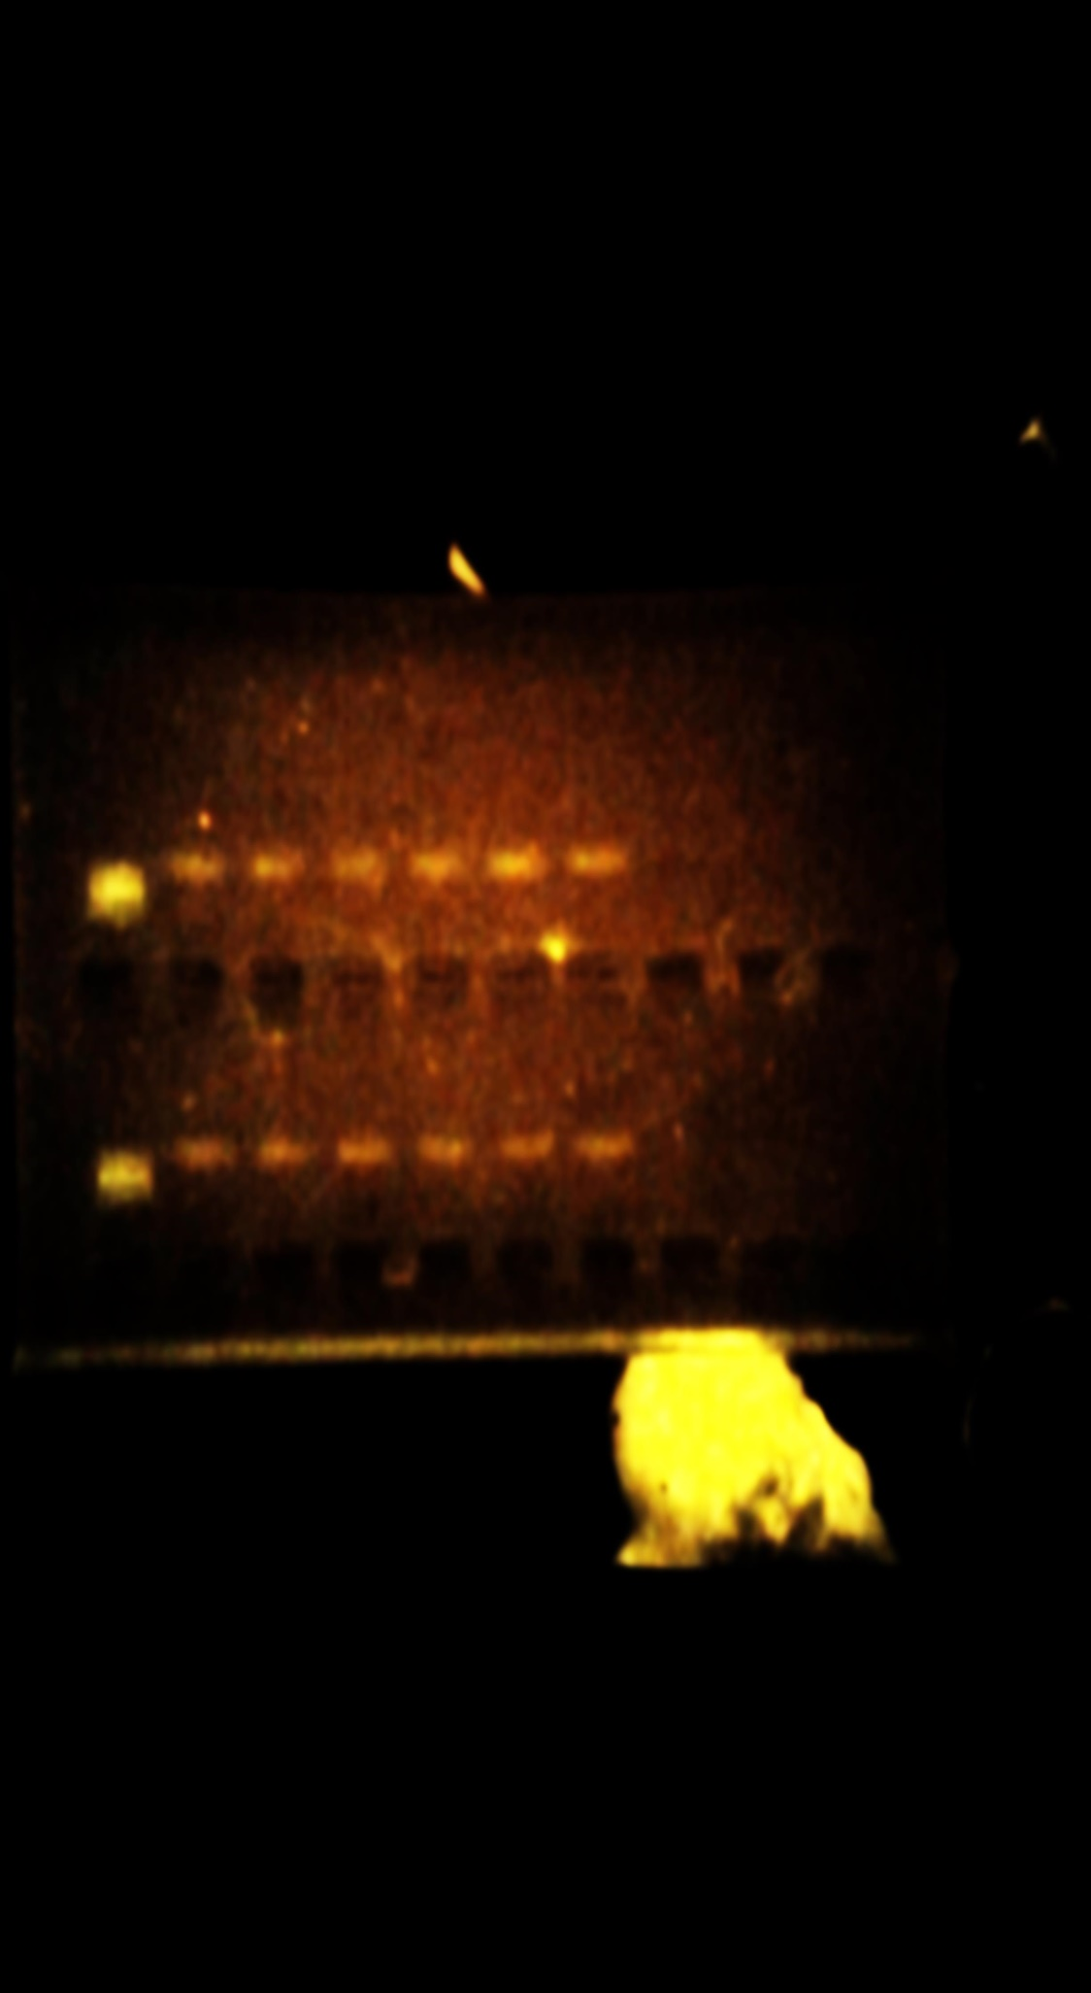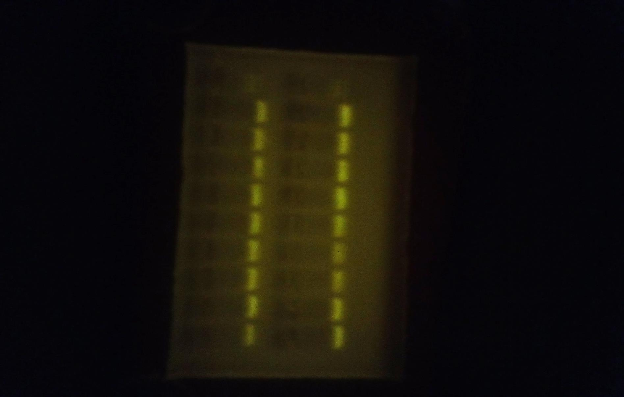

VISFATIN

B-ACTIN

VISFATIN

B-ACTIN

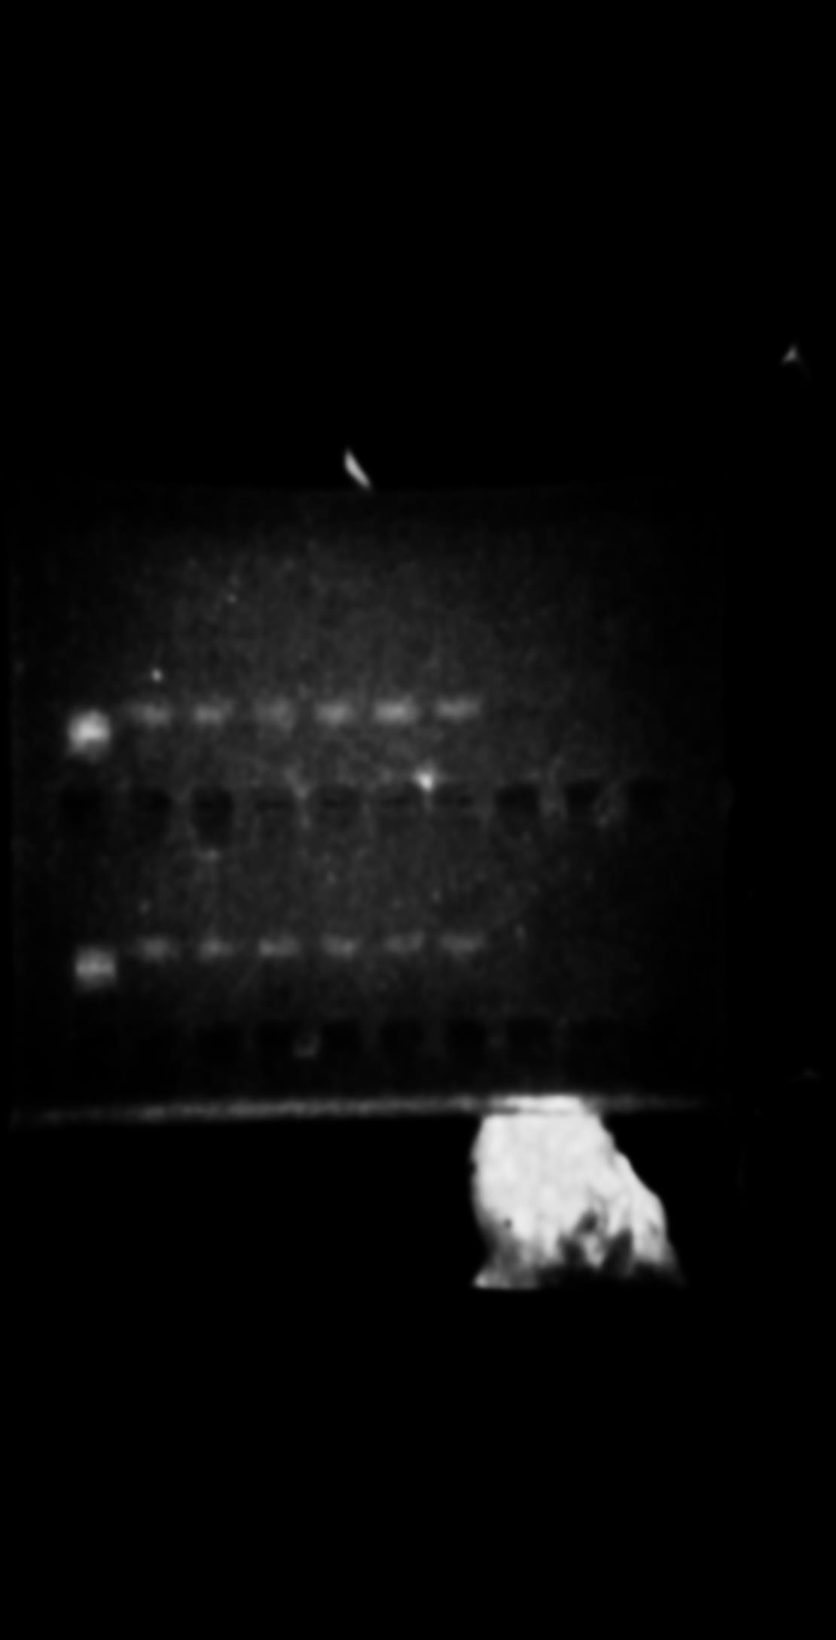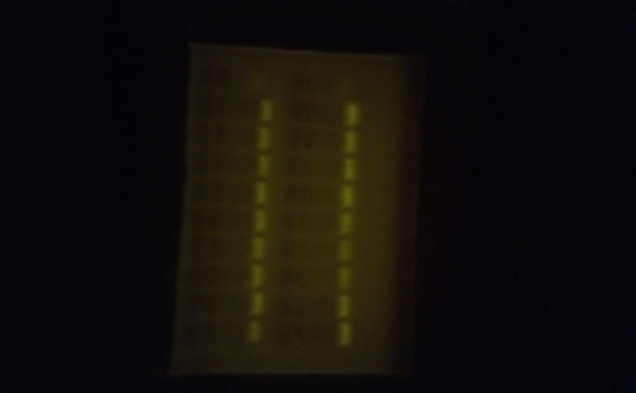



**FIGURE 6: mRNA expression of visfatin.**

**DISCUSSION:**

The findings from this research show a progressive significant increase in visfatin concentration when it was compared between the Normotensive menopausal women and the hypertensive menopausal women.

These hypertensive (HTN) subjects revealed a significant increase in their superoxide dismutase (SOD) and catalase (CAT) antioxidant activities when compared with the normotensive subjects. from the results, there is a positive relationship between visfatin and catalase activity.

PBEF-1 was used to investigate the role of visfatin in premenopause, menopause and hypertension amongst women. In order to establish gene expression profile, the fomular below was used:

$$\frac{the expressed value of visfatin in the sample}{B actin in the same sample}=gene expression profile of visfatin.$$

B actin was used as an internal control to stabilize the expression of visfatin gene.

Results reveal a progressive increase in mRNA expression of visfatin in NT from preM to periM to postM phases. This was typified by the progressive increase in thickness of the RNA bands. This is therefore indicative of increased adipose tissue mass with increase in age. There is also a thickening of the bands between the preM and periM hypertensives due to an increase in secretion of adipokines by the adipose tissue seen in conditions such as hypertension. Figure 7 shows a possible mechanism by which visfatin acts and its possible relationship with reactive oxygen species .

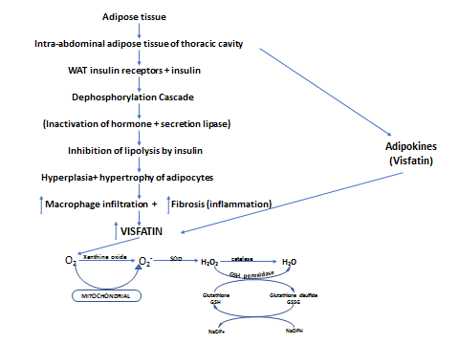

**Figure 7: Possible mechanism for visfatin synthesis and its relationship with oxidative stress.**

Adipokines are more expressed as pro-inflammatory cytokines during hypertension (Romacho *et al.,* 2013). Visfatin at high concentration attract immune cells and causes chronic inflammation in adipocytes (Kumari et al., 2018). This study also reveals serum as the most viable sample for assessing visfatin levels in humans.

An increase in adipose tissue mass associated with increase in age amongst women, can lead to a gradual accumulation of fat in the intra-abdominal region which include perivascular and epicardial fat. This increase can lead to a corresponding increase in white adipose tissue (WAT). WAT of greater than 30-35% value in the perivascular and epicardial fat contain insulin receptors. There is an increase in insulin receptors and an increase in insulin binding. Insulin inhibits lipolysis by initiating a dysphosphorylation cascade. Hyperplasia and hypertrophy of adipocytes results from inhibition of lipolysis which trigger an infiltration of macrophages and the resultant increase in inflammation or fibrosis of these adipocytes. Visfatin concentration therefore increases in response to reactive oxygen species with a proportionate increase in superoxide dismutase (SOD) and catalase (CAT) antioxidant enzymes.

**REFERENCES**

* Adeghate, E. 2008. Visfatin: structure, function and relation to diabetes mellitus and other dysfunctions. *Current medicinal chemistry*, *15*(18), pp.1851-1862.
* Adeloye, D., and Basquill, C. 2014. Estimating the prevalence and awareness rates of hypertension in Africa: a systematic analysis. *PloS one*, *9*(8), e104300.
* Amal, H.A. 2018-2020 urine collection manual; Hamad Medical Corporation, Department of Laboratory Medicine and pathology, College of American pathologists.
* Belo, V. A., Luizon, M. R., Lacchini, R., Miranda, J. A., Lanna, C. M. M., Souza-Costa, D. C., and Tanus-Santos, J. E. 2015. The effects of NAMPT haplotypes and metabolic risk factors on circulating visfatin/NAMPT levels in childhood obesity. *International Journal of Obesity*, *39*(1), pp.130-135.
* Clark, J. H., and Greenleaf, J. E. 1971. Electronic bicycle ergometer: a simple calibration procedure. *Journal of applied physiology*, *30*(3), pp.440-442.
* Czerska, M., Mikolajewska, K., Zielinski, M., Gromadzinska, J., and Wasowicz, W. 2015. Today’s oxidative stress markers.
* Dahl, T. B., Yndestad, A., Skjelland, M., Øie, E., Dahl, A., Michelsen, A., and Halvorsen, B. 2007. Increased expression of visfatin in macrophages of human unstable carotid and coronary atherosclerosis: possible role in inflammation and plaque destabilization. *Circulation*, *115*(8), pp.972-980.
* D.G, Dayyal 2018. ["Procedures for the collection of blood for hemotological investigations"](https://www.bioscience.com.pk/topics/hemotology/item/796-procedures-for-the-collection-of-blood-for-hemotological-investigations). *BioScience Pakistan*. BioScience Pakistan. [ISSN](https://en.wikipedia.org/wiki/ISSN_(identifier)) [2521-5760](https://www.worldcat.org/issn/2521-5760).
* Dogru, T., Sonmez, A., Tasci, I., Bozoglu, E., Yilmaz, M. I., Genc, H., and Bingol, S. 2007. Plasma visfatin levels in patients with newly diagnosed and untreated type 2 diabetes mellitus and impaired glucose tolerance. *Diabetes research and clinical practice*, *76*(1), pp.24-29.
* Fain, J. N., Madan, A. K., Hiler, M. L., Cheema, P., and Bahouth, S. W. 2004. Comparison of the release of adipokines by adipose tissue, adipose tissue matrix, and adipocytes from visceral and subcutaneous abdominal adipose tissues of obese humans. *Endocrinology*, *145*(5), pp.2273-2282.
* Fukuhara, A., Matsuda, M., Nishizawa, M., Segawa, K., Tanaka, M., Kishimoto, K. and Shimomura, I. 2005. Visfatin: a protein secreted by visceral fat that mimics the effects of insulin. *Science*, *307*(5708), pp.426-430.
* González, J., Valls, N., Brito, R., and Rodrigo, R. 2014. Essential hypertension and oxidative stress: New insights. *World journal of cardiology*, *6*(6), pp.353.
* Hassan, M., Latif, N., and Yacoub, M. 2012. Adipose tissue: friend or foe?. *Nature Reviews Cardiology*, *9*(12), pp.689-702.
* Henson, B. S., and Wong, D. T. 2010. Collection, storage, and processing of saliva samples for downstream molecular applications. In *Oral Biology* pp.21-30. Humana Press, Totowa, NJ.
* Kearney, P. M., Whelton, M., Reynolds, K., Muntner, P., Whelton, P. K., and He, J. 2005. Global burden of hypertension: analysis of worldwide data. *The lancet*, *365*(9455), pp.217-223.
* Kocelak, P., Olszanecka-Glinianowicz, M., Owczarek, A., Bożentowicz-Wikarek, M., Brzozowska, A., Mossakowska, M. and Chudek, J. 2015. Plasma visfatin/nicotinamide phosphoribosyltransferase levels in hypertensive elderly–results from the PolSenior substudy. *Journal of the American Society of Hypertension*, *9*(1), pp.1-8.
* Kumari, S., Badana, A. K., and Malla, R. 2018. Reactive oxygen species: a key constituent in cancer survival. *Biomarker insights*, *13*, 1177271918755391.
* Lee, W. J., Wu, C. S., Lin, H., Lee, I. T., Wu, C. M., Tseng, J. J., and Sheu, W. H. 2009. Visfatin-induced expression of inflammatory mediators in human endothelial cells through the NF-κB pathway. *International journal of obesity*, *33*(4), pp.465-472.
* Lu, X., Guo, J., Wang, Y. and Quan Z. 2016. The relationships between serum levels of visfatin and hypertension. *American journal of hypertension* 30(1), pp.102
* Mansego, M. L., Redon, J., Marin, R., González-Albert, V., Martin-Escudero, J. C., Fabia, M. J., and Chaves, F. J. 2008. Renin polymorphisms and haplotypes are associated with blood pressure levels and hypertension risk in postmenopausal women. *Journal of hypertension*, *26*(2), pp.230-237.
* Martin, P.R., Shea, R.J., and Mulks, M.H. 2001. J. Bacteriol. 183, pp.1168–1174.
* Ong, K. L., Cheung, B. M., Wong, L. Y., Wat, N. M., Tan, K. C., and Lam, K. S. 2008. Prevalence, treatment, and control of diagnosed diabetes in the US National Health and Nutrition Examination Survey 1999–2004. *Annals of epidemiology*, *18*(3), pp. 222-229.
* Rongvaux, A., Shea, R. J., Mulks, M. H., Gigot, D., Urbain, J., Leo, O., and Andris, F. 2002. Pre‐B‐cell colony‐enhancing factor, whose expression is up‐regulated in activated lymphocytes, is a nicotinamide phosphoribosyltransferase, a cytosolic enzyme involved in NAD biosynthesis. *European journal of immunology*, *32*(11), pp.3225-3234.
* Samal, B., Sun, Y., Stearns, G., Xie, C., Suggs, S. and McNiece, I., 1994. Cloning and characterization of the cDNA encoding a novel human pre-B-cell colony-enhancing factor. *Molecular and cellular biology*, *14*(2), pp.1431-1437.
* Schunkert, H., Ingelfinger, J. R., Hirsch, A. T., Tang, S. S., Litwin, S. E., Talsness, C. E., and Dzau, V. J. 1992. Evidence for tissue-specific activation of renal angiotensinogen mRNA expression in chronic stable experimental heart failure. *The Journal of clinical investigation*, *90*(4), 1523-1529
* . Ugwu, A.C. and Oyebola, D.D.O., 1996. Sweat collection made easy. *J Med Lab Sci*, *5*, pp.171-6.
* Wang, J.Y., Wen, L.L., Huang, Y.N., Chen, Y.T. and Ku, M.C., 2006. Dual effects of antioxidants in neurodegeneration: direct neuroprotection against oxidative stress and indirect protection via suppression of gliamediated inflammation. *Current pharmaceutical design*, *12*(27), pp.3521-3533.
* Hai-xia, B.I.A.N. and Hong-bing, Z.H.A.N.G., 2015. Relationship of Adipokines and Vascular Disease Related Factors in Diabetic Retinopathy. *Journal of Kunming Medical University/Kunming Yike Daxue Xuebao*, *36*(1).
* Yoshikawa, T. and Naito, Y., 2002. What is oxidative stress?. *Japan medical association journal*, *45*(7), pp.271-276.