Study of the effects allelopathic of the exotic plants on natural regeneration. Case of Eucalyptus déglupta (B.), 1863, E. urophilla( S. T. B.), 1977, E. camaldulensis (D.), 1832, E. citriodora( H.), 1848, Pinus caribaea ( M.), 1851 et Gmelina arborea (R.), 1814 on the growth of Cesalpina pulcherima( L.), Sw., 1791, at hill of Gbazoubangui, (Central African Republic)

Ndotar Michel¹, Joseph Martin Bell ², Kosh-Komba Ephrèm³, Kamba-Mebourou Emmanuel⁴, Bombo-Yongo Olga D³, Sylla. Sembala⁴
1, Laboratory of the ground and life sciences, Higher Teacher training school, University of Bangui, Central African Republic. E-mail : ndotarmich@yahoo.fr B. P 1450 E.N.S University of Bangui, Central African Republic.
2. Laboratory of Vegetal biology, University of Yaounde I, Camroon
3. Laboratory of Vegetal Biodiversity and Fungic, Faculty of Science, University of Bangui, Central African Republic.
4 Laboratory of Biological and Agronomical Sciences for Development, Faculty of sciences, University of Bangui, Central African Republic

ABSTRACT: In the optics of stage to problems of deforestation and desertification in the threatened areas tropical, of monocultures of the species of the exotic plants are used in the natural environments. The objective of this study is to evaluate the impact of the pastes of the sheets of 4 species of Eucalyptus, of Pinus caribaea (Mr.) and of Gmellina arborea ( R.) on the growth of Cesalpina pulcherima (L.) and to check the influence of exudates roots of these plants in Co-culture with Cesalpina pulcherima (L.) a device of experimental culture was used, as well as a variance analysis (ANOVA) to a factor (test of Shapiro, P<0.005) and an analysis by a linear model generalized (GLM) with the distribution of errors of the family of Poisson for the analyses. All these tests have been carried out with the software R version 3.4.4. The results of the tests go up that the pastes of E. urophilla (S. T. B ), E. deglupta (B.) and E. camaldulensis (D.) significantly accelerate the growth in height of C pulcherima (L.), on the other hand the pastes of Ecitriodora (H.), no effect has. No effect on the diameter of the stems of C. pulcherima (L.), (ANOVA, P>0.05, n=40). A significant result of the growth with E. urophila (S;T.B.) .,< https://en.wikipedia.org/wiki/Stanley_Thatcher_Blake >. and G. arborea (R.) then no effect with P. caribaea (M.) No effect on the growth in thickness of the stems of C. pulcherima (L.), (ANOVA, P>0.05, n=40)..A significant inhibition of the growth in length of C pulcherina (L.) in Co-culture with E. deglupta (B.),P. caribaea (Mr.) and G. arborea (R.). Theaverage heights of C. pulcherina (L.) in Co-cultivated are significantly lower than that of the witness (P<0.005).
KEY WORDS: Allelopathy, exotic plants, Cesalpina pulchrima (L.) hill of Gbazoubangui, Central African Republic.
Introduction

The increasing needs for the man with regard to the forest and the economic development of certain countries based primarily on the exploitation of the natural resources gave place to the various shapes of exploitations of the tropical forest. Thus, the tropical forest is subjected to various forms of destruction such the industrial exploitations by the forest companies, the industrial plantations (coffee, cocoa, palm tree with oil, banana plantation, the firewood and the production of coal( Whittaker R. H., 1970).These various forms of exploitations pose of serious problem of forest management blocking the capacity of the forests thus to be regenerated . The pressures of the population cause a retreat of the tropical forest of 100 000 to 200 000 ha per year, that is to say an annual rate from 0,3% to 1% (Inderjit, 2005)). The forest countries, other countries threatened by the problem of deforestation and desertification and the organizations of nature conservancy, conscious of the width of these problems, propose several solutions. Some propose stronger forest codes to protect their forest, others propose the classification of the zones in reserves and park, others still propose the artificial plantations on base of the exotic species like alternative to deforestation and the desertification (Sanon A., Ndoye F. & Duponnois R., 2012).. In many cases, the exotic plants have been largely used because of their ecological plasticity, their fast growth which often constitute a real advantage (for the wood energy supply in particular), and for good of other interests (ecological: stabilization of the dunes, rehabilitation of the grounds, fertilization of the grounds, phytoremediation, restoration of the microclimate, to desiccate the flooded mediums; socio-economic: provision of fruits, fibers, fodder, gum, tannins, drugs, wood of service (Siddiqui, Z. A. & Pichtel, J., 2008).Environmental impact studies related to the use of these exotic gasolines later gave negative ecological effects which often modify the properties of the ecosystem host in order to promote their own installation and their adaptation (Bernhard-Reversat F.n, 1987, Calder I. R., Hal lR. L. & Prasanna K. T., 1993, Siddiqui, Z. A. & Pichtel J., 2008, Kisa M., Sanon, A., Thioulouse J., Assigbetse K., Sylla S., Spichiger R., Dieng L., Berthelin J., Prin Y., Galiana A., Lepage M. & Duponnois R., 2007). In addition to their effect on the composition and operation of the ecosystem hosts, the exotic species can become threats for the biodiversity which however is essential to the durability of the ecosystems and the provision of the vital ecosystem services (Sanon A., Ndoye F. & Duponnois R., 2012).The threats of the planted exotic species are related to various allopathic effects defined in the years 1937 by the Austrian Hans Molish (Wirsel S. G. R., 2004). The origin of the word comes from the Greek, allélo each other and pathos (suffering/effect).Thus the etymology of this word implies that these interactions are negative: competitions for the resources, mechanisms of defense. The current acceptance of the allelopathy also included of the positive interactions like the phenomena of co-operation and stimulation of the micro-organisms. These interactions are done by the intermediary of the compounds known as allelopathic, released by the plant in its medium. Generally these compounds are secondary metabolites and belong to very varied biochemical families Ils can be released by the roots (exudation), the air parts (leaching volatilization) or by the decomposition of the residues of the dead plants (Sophie Q. & Sandrine O. 2017). The allelopathy also indicates the emission or the release by a body of a vegetal species, alive or died, toxic organic substances involving the inhibition of the growth of the plants developing in the vicinities of this species or succeeding to him on the same ground( Willis R. J., 2010), Romagni J. G., Allen S. N. & Dayan F. E., 2000).. The study of this phenomenon experienced a fast and very significant development in agronomy. Currently, the ecology of the emission of the inhibiting substances implied in the chemical interactions between plants is today in development in the field of the forestry especially for the afforestation of the arid and desert mediums. The species belonging to the Pinus Eucalypti, Gmelina and Tectona and the cassias are exotic plants the most used in afforestation and the most employed in Africa in the countries threatened of desertification and deforestation and particularly in Central African Republic. The installation of a plantation corresponds to a destruction of the existing local vegetal flora. These exotic species impose their mechanisms of life and prevent the local species to be regenerated.
The general objective of this study is to seek the mechanism of the impact of the exotic plants; E. deglupta(B.), E. urophylaeS.T.B) <https://en.wikipedia.org/wiki/Stanley_Thatcher_Blake >., E. camaldulensis (D.), E. citriodora., Pinus caribaea(Mr)., and Gmelina arborea (R.); on the growth of Cesalpina pulcherima( L.) and in a specific way of:
- To study the impact of the pastes of thefresh sheets of Eucalyptus deglupta (B.), Pinus caribaea, (Mr.) and Gmelina arborea (R.) on the growth of Cesalpina pulcherima( L.)
- To study the effect of the exudates root of Eucalyptus deglupta (B.), Pinus caribaea (M.), and Gmelina arborea (R )on the growth of Cesalpina pulcherima (L.)

MATERIALS AND METHODS 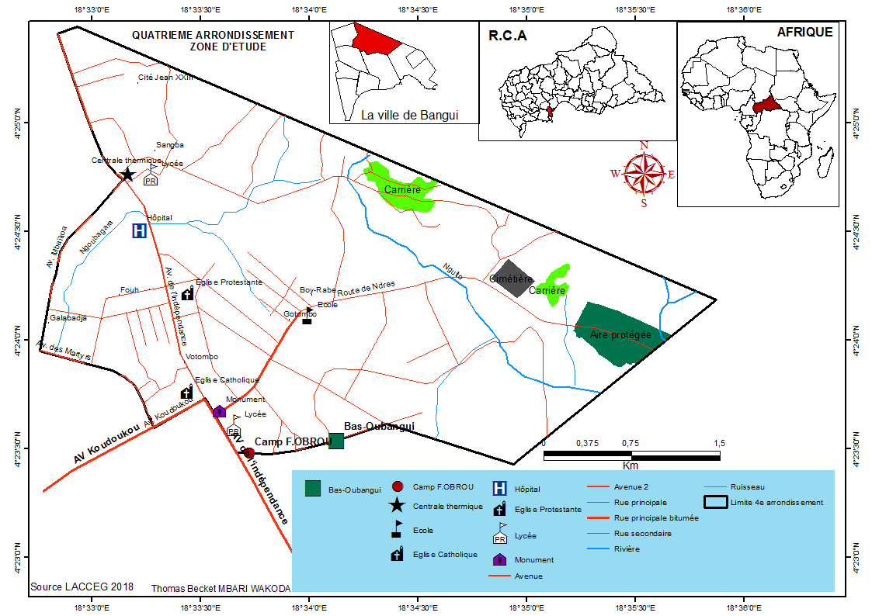
Figure 1 : Localization of the zone of study

Study area
The study was conducted at hill of Gbazoubangui, (Central African Republic)
The special reserve protected area of the forest of the hills of Gbazabangui (Figure 1) is located at 581 meters of altitude above the town of capital Bangui of the RCA.. It is localized with the intersection of ô 22' 37 and ô 24' 39 of northern altitude and 18o 34' 08 and 18o 36' 20 of longitude. The protected field covers a area of 915 ha of which a surface protected from 383 ha and a field with agroforestry activities controlled of 532 ha with weak slopes towards the North-West. All the area has a under-climate oubanguian with 6 months of wet period, 3 months of intermediate period and 3 months of dry period.
The annual average pluviometry of 1537 mm is distributed over 130 days with the maximum of precipitation in September July-August. The annual average temperature is 26C. The ground consists of Precambrian rocks covered by spots of tertiary and quaternary formations. he framework of the hill of Gbazabangui is consisted of the Schists in partnership with the quarzites. The forest area is consisted of the mesophylls species, semi caducous like Celtis Mildbraedii, Triplochiton scleroxylon, Terminalia superba and of the species known as degraded because of the clearings and the cultures such as Elaeis guineensis,Musanga cecropioides and Pycnanthus angolensis. The field of forest savanna perished represents a shrubby savanna with dominant species like; Elaeis guinéensis, Annona senegalensis, Hymenocardia acida, Sarcocephalus esculentus, Bridelia ferruginea, Afromomum sanguineum. As herbaceous layer we finds in it Imperata cylindricum there, Panicum maximum, Loudetia arundinacea and Chromolaena odorata.
Method of test

Test of the effect of the pastes of the fresh sheets of 4 species of Eucalyptus on the growth of Cesalpina pulcherima (L.)
The experimental device was composed of 5 blocks of 20 packets of seedbeds. The packets are filled with ground of the site. Seeds of Cesalpina pulcherima L., were sown in the packets at a rate of 3 seeds per packets. The packets are sprinkled by pure water. After germination only one young growth was maintained in each packet. The sheets of the Eucalyptus citrriodora (H)., Eucalyptus camaldulensis (D), Eucalyptus urophilla (S.T..B.) and Eucalyptus deglupta (B.) are collected, crushed and the pastes obtained are placed in 4 containers different corresponding to each species from Eucalyptus. One kilogram of paste of each species is mixed with 5 liters of water and is preserved during 72 hours so as to have a quite homogeneous mixture. Each group of packet is sprinkled by the macerated product of each species of eucalyptus at a rate of 200 ml of mixture per packet. The reference group of 20 packets is sprinkled by pure water. The treatment begins one week after the germination of seeds of C. pulcherina( L.) and every day the morning. The experiment is repeated twice with the ground of the same site. Each experiment had lasted three (3) months.
Test of the effect of the pastes of the fresh sheets of Pinus caribaea (M.), Gmelina arborea( R.) and of Eucalyptus deglupta (B.) on the growth of Cesalpina pulcherima (L.)
The experimental device was the same as the first experiment, but 4 blocks of 20 packets were used. Seeds of Cesalpina pulcherima (L.) were sown in the packets at a rate of 3 seeds per packets. As the preceding experiment after germination only one young growth was maintained in each packet, 3 blocks were sprinkled with the pastes of the fresh sheets species Pinus caribaea (M.), Gmelina arborea (R.), Eucalyptus deglupta (B.) and a pilot block sprinkled with pure water. The experiment is followed like the preceding one for 3 months and is repeated twice
The allopathic effect of the exsudats of the roots of the Eucalyptus deglupta B, Pinus caribaea(Mr.) and Gmelina arborea (R.) on the growth of Cesalpina pulcherima( L.)
For this experiment 80 packets of young growths of Cesalpina Pulcherina L. are prepared as for the preceding experiment.
Seedbeds of the Eucalyptus, Pinus and Gmelina have been prepared on boards. A Co-culture of 20 packets by species is carried out with the young growth of Cesalpina Pulcherina (L.) The pilot block of 20 packets including 5 packets for the young growths of Cesalpina pulcherima (L.), 5 packets for Eucalyptus deglupta (B.), 5 packets for Pinus caribaea (M.) and 5 packets for Gmelina arborea R. The packets are sprinkled with pure water for 3 months.
Measured and observed Parameters
. For tests 1, 2 and the 3 parameters which were the subject of measurements are the height of the stems and the diameters of the young growths in the packets. The instruments of measurements used are; measure ribbon for the height of the stems and slide caliper for the diameters. This measurement was made each one week.
Data analysis
Data of the treatments of the young growths of C. pulcherina L. with the pastes of the fresh sheets of the species of the Pinus, Eucalyptus and Gmelina . have been compared by a variance analysis (ANOVA) with a factor because these data follow a normal distribution (test of Shapiro, P<0.005).In case of significant difference, the test post hoc of Tukey is used to detect the heights and the diameters which are statistically different. For the data of Co- cultures (two young growths of different species in the same packet), the heights and diameters have been analyzed by a linear model generalized (GLM) with the distribution of errors of the family of fish. All these tests have been carried out with the software R. version 3.4.4 and the differences are considered significant for P≤0.05.
Results and Discussion

Agronomic performances of the young growths of C. pulcherima (L) treated with the pastes of the fresh sheets of the Eucalyptus
The results show that the treatment with the pastes of E urophilla (S.T.B)., E. deglupta (B.) and E .camaldulensis (D. ) significantly accelerate the growth in length of the young growths of C. pulcherima (L,) which passes 12, 85 cm (pilot) to at least 14.2 cm on average for three months of observation (ANOVA, P<0.05, n=40). The treatment with the pastes of E. .citriodora (B. ) does not have, on the other hand, no effect on this growth in length compared with the pilot. Whatever the species of Eucalyptus used, the macerated products do not have any effect on the diameter of the stems of C. pulcherima (L.) (ANOVA, P>0.05, n=40)
(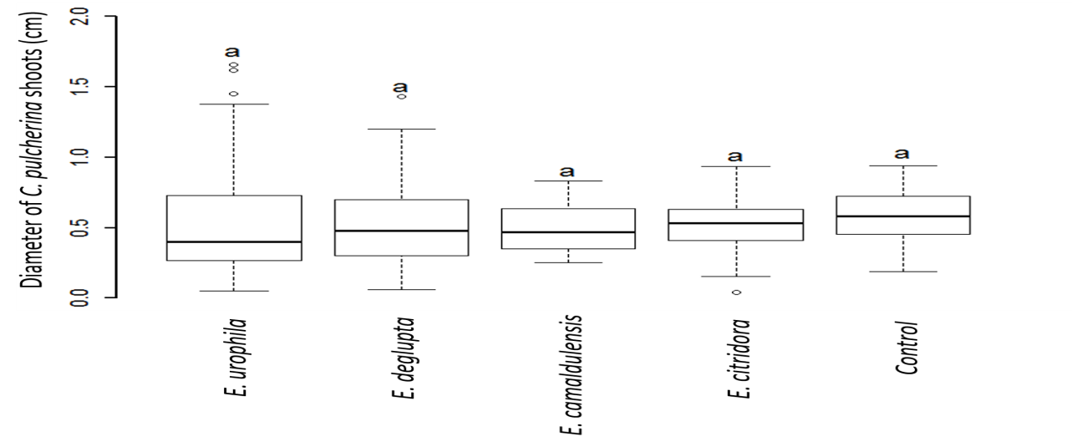
Figure 2. Box studs of the agronomic parameters of the young growths of C. pulcherinae L.) exits of treatment by pastes of the sheets of the four species of Eucalyptus (E. urophilla (S.T.B.), E. deglupta( B.), E. camaldulensis (D.) and E.citridora (B.). The boxes studs with different letters are significantly different from the others (ANOVA, P<0.05, n=40).
These results obtained with the pastes of the fresh sheets of 4 species of Eucalyptus show that the fresh sheets these species support the growth of the young growths of Cesalpina pulcherima (L..) The compounds in the fresh sheets of the species of Eucalyptus constitute a nutritive source which accelerates the growth of the young growths of Cesalpina pulcherima (L..); Whereas it was brought back by other studies that the many exotic plants had the capacity to produce compounds allelopathic; what would explain (partly) the expansion of many exotic plants in the biotopes hosts where some become finally invasive leading to the installation of a specific mono settlement (Calder, I. R., HallR. L. & Prasanna, K. T., 1993), Sanon A., Ndoye F. & Duponnois R., 2012)., Weston L. A. & Duke S. O.,(2003). , Lind E. M. & Parker J. D., 2010).. A quebecois team tried in agronomy to fight by allelopathy against invasion by rubusidaeus, itself suspected to produce compounds allelopathic with respect to semis of Picea mariana. This team showed that incorporation on the soil of cereal residues (oats, barley and wheat), reduced the development of Rubusideaus appreciably, while improving the growth of sowing of Pines. On the other hand the vegetable residues can be to freezing, or the mechanical and left destruction on the area under plantation or in inter culture have also a depreciating effect on the adventitious ones because they form a physical barrier limiting the lifting of adventitious and especially natural regeneration. These studies show that the mechanism of action of the species of Eucalyptus appears through the residues in decomposition (litter) and not of compounds in the fresh sheets. These authors showed that the vegetable covers exert a competition vis-à-vis to adventitious for water, the nitrogen, the light. This competitiveness of the forks and spoons depends on the intrinsic factors like the port of the plant, the height, the speed of growth and the factors like the methods of establishment (Tchatchou B., Sonwa D., IFO, S. & Tiani A., 2015). The effect allelopathic of the Eucalypti, Pinus and Gmelina tightened especially due to their port, their fast growth, the development of their canopy which prevents the light with the realization of the photosynthetic phenomenon of the plants of the under wood (Tchatchou B., Sonwa D., IFO, S. & Tiani A., 2015) and the accumulation of residues of the dead sheets which would form a physical barrier for the lifting of the other plants and others in decomposition which would modify the physicochemical composition of soil.

Agronomic performances of the young growths of C pulcherima L. treated with the pastes of the fresh sheets of E deglupta B., P. caribaea M. and G arborea R.
The pastes of the fresh sheets of E. urophilla (S.T.B.) and G. arborea (R.) significantly accelerate the growth in length of the stems of C. pulcherima (L. ) who passes from 12, 85 ± 1.5 cm (pilot) to at least 13.3 ± 2.12 cm on average for three months of observation (Figure 3).The product of P. caribaea (Mr.) did not have any effect. None of these vegetal species (E. deglupta (B,) P. caribaea( M.) and G. arborea (R.) did not have effect on the growth in thickness of the stems of C. pulcherima L. (ANOVA, P>0.05, n=40; Figure 3).
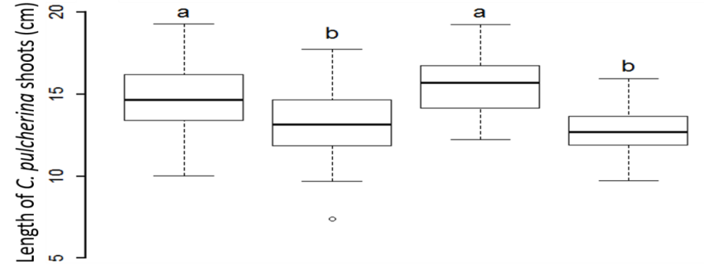
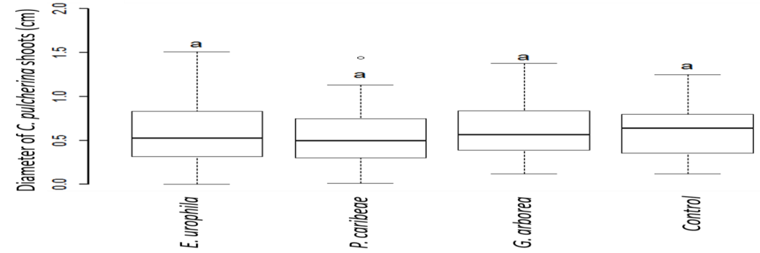
Figure 3. Box studs of the agronomic parameters of the young growths of C. pulcherina (L). exits of treatment by pastes of P. caribaea( M.), G. arborea (R.) and E. urophilla( S.T.B. ) .The boxes studs with different letters are significantly different (ANOVA, P<0.005, n=40).
The results obtained with the sheets of the three species of the exotic plants show that the existing biochemical compounds in the fresh sheets of E. deglupta (B.)and G. arborea (R). Accelerate significantly the growth of C. pulcherima (L.) instead of inhibiting some. Paste of thefresh sheets of P. caribaea( M.) has not any effect. This result can be to the quality of the paste of P. caribaea( M.). the needles of P. caribaea (M. )are very hard to crush. The paste obtained is not consistent and the nonhomogeneous solution contains fibers of the needles whereas with the species E. deglupta (B.) and G. arborea( M.) The pastes are quite consistent and give homogeneous solutions. The difference is not significant for the diameter growth of the young growths of C. pulcherima (L.) in the packets (P>0.05). Like the study of the allelopathic effects of the freshsheets of the species of Eucalyptus, there is no effect for inhibition of the growth of C. pulcherima (L.) According to the studies done on the Eucalyptus, Pinus, and Gmelina, these plants are species which adapt to all climatic conditions and often employed in the world to resolve with problems involved the desertification and deforestation. That explains why the afforestation is made in a degraded medium. The degradation of vegetal cover is generally the first visible symptom of the desertification, but this state of degradation often is accompanied or preceded by profound disturbances by the physicochemical and biological properties of soil (Rice, E. L.,1984),. (Cardoso, I. M. & Kuyper, T. W., 2006), Stinson, K. A., Campbell S. A., Powell J. R., Wolfe B. E., Callaway R. M., Thelen G. C., Hallett S. G., Prati D. & Klironomos J. N., 2006).. But, these properties largely determine quality and the fertility, therefore the productive capacity of soil. The negative action of the exotic plants like Eucalyptus, Pinus and Gmelina on the local plants appears especially by competitiveness for water, the nutritive resources, the light, the mode of establishment (monoculture or not, the chemical physico composition of soil) a standardization to the access to the nutritive resources with water between the dominant vegetal species (Eucalyptus, Pinus and Gmelina), (Kisa, M., Sanon, A., Thioulouse, J., Assigbetse K., Sylla, S., Spichiger, R., Dieng, L., Berthelin, J., Prin, Y., Galiana, A., Lepage, M. & Duponnois, R. 2007) .and those which of it are less (herbaceous annual, and ligneous family of the underwood (WIRSEL, S. G. R. 2004.) can facilitate the regeneration of the local species. The use of the mycozhian mushrooms .by the means of the telluric micro-organisms (mycorhizes) capableof degraded, transformed or mineralized made up organics of which the allelopathic substances which will become inactivated (Inderjit 2005). The mycorhizian mushrooms with arbuscules and the mycorhizospheric microflora which is associated for them were described like potential biological agents able to metabolize the allelochimic compounds( Pellissier F. & Souto X.. C., 1999, Blum U., Staman K.L., Flint, L. J. & Shafer, S. R., 2000) By this mechanism, the mycorhizian mushrooms and they microflora associated can thus, indirectly, protect the herbaceous vegetal species and the ligneous family from the underwood of these harmful substances released by the exotic species, promoting by the same occasion the vegetal biodiversity and the productivity of the ecosystem.
Agronomic performances of the young growths of C. pulcherima( L.) Co-cultivated with E. deglupta (B.), P. caribaea (M.) and G. arborea (R.)
We observe a significant inhibition of the growth in length of the young growths of C.pulcherina L. when those have been put in culture with the growths of E. deglupta (B.), P. caribaea (Mr). and G. arborea (R).. The average length of the young growths of C. pulcherina (L.) cultivated with G. arborea( R.) is of 10.7 ± 1.72 cm, very significantly lower than that of the pilot that is of 13.08 ± 2.53 cm (P < 0.005;Table 1).In the same way, average lengths of the growths of C. pulcherina (L.) cultivated with E. deglupta (B). and P. caribaea (Mr). of 10.9 ± 2.5 cm are significantly lower than that of the witness (P < 0.005;Table 1). No statistical difference was found when one compares the diameters of the growths of C. pulcherina (L.) (in Co-culture with other species) with that of the pilot (P > 0.05; Table 1).
Table 1.Comparison by a generalized linear model (distribution of errors of the family of fish) of the agronomic performances of the young growths of C. pulcherina( L.) co-cultivated with the growths of E .deglupta( B.,) P. caribaea ( Mr.) and G. arborea (R.)
Comparison of lengths of shoots
 |  | Length (cm) of C. pulcherina shoots grown together with Xª |  | Estimate | Std. Error | z value | Pr(>|z|)
Control (C. pulcherina L. itself) |  | 13.08±2.53
E. deglupta B. |  | 10.9±2.59 (16.3.9±1.79) |  | -0.16467 | 0.06512 | -2.529 | 0.01145 *
G. arborea R. |  | 10.7±1.72 (15.7±2.02) |  | -0.18233 | 0.06543 | -2.786 | 0.00533 **
P. caribaea M. |  | 10.9±2.57 (15.1±1.87) |  | -0.16467 | 0.06512 | -2.529 | 0.01145 *
 |  | Length (cm) of the shoots when two shoots of the same species were grown together
Comparison of diameters of shoots
 |  | Diameter (cm) of C. pulcherina L. shoots grown together with Xª |  | Estimate | Std. Error | z value | Pr(>|z|)
Control (C. pulcherina L. itself) |  |  | 0.57±0.11
with E. deglupta B. |  |  | 0.45±0.13 (0.7±0.11) | -0.2483 | 0.3158 | 0.3158 | 0.43179 ns
with G. arborea R. |  |  | 0.49±0.09 (0.8±0.20) | -0.1645 | 0.3086 | 0.3086 | 0.59404 ns
with P. caribaeaM. |  |  | 0.46±0.16 (0.7±0.15) | -0.2477 | 0.3157 | 0.3157 | 0.43276 ns
Lengths or diameters are presented as mean ± standard deviation (values in parentheses and with bold characters are lengths or diameters when two shoots of the same species were grown together).Statistical Significance codes (statistical comparisons are made with the lengths and the diameters of the control):
***P<=0.0001; **P<0.001; *P<0.05, ns = non-statistical difference. (a) X= E. deglupta, (B.) G. arborea (R.), P. caribaea (M. ) or control.
These results well confirm former work carried out on the ground for the construction of a green belt from Senegal to Djibouti (Sophie Q. & Sandrine O. 2017). Seedlings of Gmelina and Eucalyptus therefore have been cultivated in the soil not sterilized, what has allowed the development of the herbaceous exits of the endogenous seed stock in the soil. According to these authors, growth of annual adjacent herbaceous with the seedlings of G. arboraea (R.) or E. camaldulensis (D.) is strongly inhibited when the seedlings were cultivated without preliminary treatment (example: without controlled mycorhization). This inhibiting effect was the resultant of the competition between vegetal species for the available resources and would thus ensure a competitive advantage to the exotic gasolines (Sophie Q. & Sandrine O., 2017). According to the studies undertaken on the mechanism of action of these species (among the mechanisms of action blamed, it is a case of the direct allelopathy on the herbaceous ones (Sanon A., Béguiristain, T., Cébron, A., Berthelin, J., Ndoye I., Leyval C., Sylla, S. & Duponnois R., 2009). The Eucalyptus kind produces and releases in the environment of the 1,8 cinéole (Sanon A., Martin P., Thioulouse J., Plenchette C., Spichiger R., Lepage M. & Duponnois R., 2006)) .a powerful allelochimic agent that inhibits the growth of several herbaceous vegetal species. The work carried out on the afforestation and the allelopathic effects of the exotic plants showed that the modification and/or the replacement of the initial rhizospheric microflora (before afforestation with exotic gasoline) by another would explain for a significant share the naturalization and the expansion of the exotic plants at the expense of the native vegetal species (WOLFE, B. E. & KLIRONOMOS, J. N. 2005 Jordan N. R., Larson, D. L.,& Huerd, S. C., 2008),. The significant difference of the performance of the young growths obtained here shows that the phenomenon is purely a phenomenon of competition for the nutritive resources between the co-cultivated species. The performance of the species cultivated only with the same soil gives the proof. In the same way it has been suggested that the competition at the level of the soil reduced much more the performance of the plants than the competition for the light (Donald, C. M. 1958, WILSON, J. B. 1988). and would constitute the principal form of competition in the ecosystems having the low vegetal density (Fowler N., 1986)). In addition, the level of competition of the vegetal communities will depend, notably, of the special distribution of the plants, the nutritive resources in division, and of the capacity of each vegetal species or the means implemented by this one to acquire these resources( Freckleton R. P. & Watkinson A. R., 2001).Thus the differences of length between the young growths co-cultivated in the packets can be only the results of a competition for the incorporation of the nutritive resources, and the means implemented which are the rootage system of each species.
CONCLUSION AND OUTLINES
In conclusion, this study shows that the Biochemicl compounds in the fresh sheets of the exotic plants (Eucalyptus, Pinus and Gmelina) used in this experiment do not have any negative effect on the growth of the species C. pulcherima (L.). On the contrary, the pastes obtained accelerate significantly the growth of C. pulcherima (L.). In the experiment of co-culture (two plants in the same packet) there is a deceleration of the growth of C. pulcherima(L.) relative to the pilot plant cultivated alone and not a total inhibition which would lead to dead plant C. pulcherima (L.). Considering the growth of Eucalyptus urophilla (S.T.B.), Pinus caribaea( M.) and Gmelina arborea (R.) cultivated lonely in the packets, we can conclude that there is a phenomenon of allelopathy per competition for the nutritive resources available in the soil of the packets which would be at the origin of the significant differences of lengths of the co-cultivated species.
With the sight of the state of impoverishment of the soil, ecosystems due to excessive exploitation and anarchistic and with recurring droughts, the traditional afforestation with exotic plants is well alternate, but it is significant to mention that the actions of afforestation alone will be unable to reverse the current tendency of deforestation and general loss of vegetal cover and the biodiversity. The exotic plants (Eucalyptus, Pinus and Gmelina) are plants of afforestation but very often considered as awkward plants of the environment thus of the plants with allelopathic actions. The allelopathy can be also regarded as a natural strategy protecting the plants against the competitors or a strategy making it possible to improve its own performance or that of the others close plants. The comprehension of the phenomenon of allopathy appears as main factor in sciences of the vegetal organisms like the physiology of the plants, ecology, and biochemistry and to better understand the complexity of the structure of the forest ecosystems. As it should be noted as the application of law of energy Transition for the green growth (LTE) since January 1th, 2019, the use of the suitable psychopharmacological products on public parks and in the gardens of the private individuals is strictly limited and regulated. In this context, the allelopathic plants prove to be valuable means of fight against weeds.
REFERENCES
Bernhard-Reversat F., 1987. Les cycles des éléments minéraux dans un peuplement à acacia seyal et leur modification en plantation d’Eucalyptus au Sénégal. Acta Oecologia, 8, 3-16.
Blum U., Staman K.L., Flint, L. J. & Shafer, S. R., 2000. Induction and/or Selection of Phenolic Acid-Utilizing Bulk-Soil and Rhizosphere Bacteria and Their Influence on Phenolic Acid Phytotoxicity. Journal of Chemical Ecology, 26, 2059-2078.
Boulvert, Y. 1976. Notice explicative No 64. Carte pédologique de la RCA. Feuille Bangui 1/200000. Paris: ORSTOM.
Calder, I. R., HallR. L. & Prasanna, K. T., 1993. Hydrological impact of Eucalyptus plantation in India. Journal of Hydrology, 150, 635-648.
Callaway, R. M. & Ridenour, W. M., 2004. Novel Weapons: Invasive Success and the Evolution of Increased Competitive Ability. Frontiers in Ecology and the Environment, 2, 436-443.
Cardoso, I. M. & Kuyper, T. W., 2006. Mycorrhizas and tropical soil fertility. Agriculture, Ecosystems & Environment, 116, 72-84.
Donald, C. M. 1958. The interaction of competition for light and for nutrient. Australian Journal of Agricultural Research, 9, 421-435.
FAO, 2011. La situation des forêts dans le bassin amazonien, le bassin du Congo et l’Asie du Sud-Est. Rapport préparé pour le Sommet des Trois Bassins Forestiers Tropicaux.Brazzaville, République du Congo.
Fowler N., 1986. The role of competition in plant communities in arid and semiarid regions. Annual Review of Ecology and Systematics, 17, 89-110.
Freckleton R. P. & Watkinson A. R.,2001. Nonmanipulative determination of plant community dynamics. Trends Ecol Evol, 16, 301-307.
Inderjit 2005. Soil microorganisms : an important determinant of allélopathic activit. Plant and Soil, 274, 227-236.
Jordan N. R., Larson, D. L.,& Huerd, S. C., 2008. Soil modification by invasive plants: effects on native and invasive species of mixed-grass prairies. Biological Invasions, 10, 177-190.
KisaM., Sanon, A., Thioulouse J., Assigbetse, K., Sylla, S., Spichiger, R., Dieng L., Berthelin J., Prin Y., Galiana A., Lepage M. & Duponnois R., 2007. Arbuscular mycorrhizal symbiosis can counterbalance the negative influence of the exotic tree species Eucalyptus camaldulensis on the structure and functioning of soil microbial communities in a Sahelian so. FEMS microbiology ecology, 62, 32-44.
Kokamy A. & Yambere S., 1994. Erosion et dégradation des collines de Bangui. Impact sur le milieu humain. Bilan de trois années d’études (1991-1992-1993). Bangui: Services pédologique et conservation des sols/BNPCS.
Lind E. M. & Parker J. D., 2010. Novel Weapons Testing: Are Invasive Plants More Chemically Defended than Native Plants? PLOS ONE, 5, e10429.
Pellissier F. & Souto X.. C., 1999. Allelopathy in Northern Temperate and Boreal Semi-Natural Woodland. Critical Reviews in Plant Sciences, 18, 637-652.
RequenaN., Perez-Solis E., Azcón-Aguilar C., Jeffries P. & Barea J. M. 2001. Management of indigenous plant-microbe symbioses aids restoration of desertified ecosystems. Appl Environ Microbiol, 67, 495-8.
Rice, E. L., 1984. Roles of Allelopathy in Plant Pathology. In: RICE, E. L. (ed.) Allelopathy (Second Edition). San Diego: Academic Press.
1Rodriguez P., Sierra, W., Rodriguez S. & Menéndez P., 2006. Biotransformation of 1,8-cineole, the main product of Eucalyptus oils. Electronic Journal of Biotechnology, 9, 232-236. DOI: 10.2225/vol9-issue3-fulltext-28.
Romagni J. G., Allen S. N. & Dayan F. E., 2000. Allelopathic Effects of Volatile Cineoles on Two Weedy Plant Species. Journal of Chemical Ecology, 26, 303-313.
1Sanon A., Béguiristain, T., Cébron, A., Berthelin, J., Ndoye I., Leyval C., Sylla, S. & Duponnois R., 2009. Changes in soil diversity and global activities following invasions of the exotic invasive plant, Amaranthus viridis L., decrease the growth of native sahelian Acacia species. FEMS Microbiol Ecol, 70, 118-31.
Sanon A., Martin P., Thioulouse J., Plenchette C., Spichiger R., Lepage M. & Duponnois R., 2006. Displacement of an herbaceous plant species community by mycorrhizal and non-mycorrhizal Gmelina arborea, an exotic tree, grown in a microcosm experiment. Mycorrhiza, 16, 125-132.
Sanon A., Ndoye F. & Duponnois R., 2012. Reboisements à base d’essences exotiques, allélopathie et mycorhization contrôlée Améliorer la mise en œuvre de la Grande Muraille Verte. In: India, A., & Duponnois, R. (ed.) La Grande Muraille Verte : Capitalisation des recherches et valorisation des savoirs locaux.IRD Éditions. doi:10.4000/books.irdeditions.3312.
Siddiqui, Z. A. & Pichtel, J., 2008. Mycorrhixae: An overview. In: SIddiqui Z. A., Akhtar M.S. and Futai K. (ed.) Mycorrhizae: Sustainable Agriculture and Forestry. Berlin: Springer.
Sophie Q. & Sandrine O., 2017. Couverts végétaux et adventices en grandes cultures. compétition et allélopathie. https://www.fredon-npdc.com/fiches/2017___29_competition_et_allelopathie.pdf.
Stinson, K. A., Campbell S. A., Powell J. R., Wolfe B. E., Callaway R. M., ThelenG. C., Hallett S. G., Prati D. & Klironomos J. N., 2006. Invasive Plant Suppresses the Growth of Native Tree Seedlings by Disrupting Belowground Mutualisms. PLOS Biology, 4, 140.
Tchatchou B., Sonwa D., IFO, S. & Tiani A., 2015. Déforestation et dégradation des forêts dans le Bassin du Congo : État des lieux, causes actuelles et perspectives. CIFOR, Papier occasionnel 120. Bogor, Indonesie.
Weston L. A. & Duke S. O., 2003. Weed and Crop Allelopathy. Critical Reviews in Plant Sciences, 22, 367-389.
Whittaker R. H., 1970. The biochemical ecology of higher plants. In: SIMEONE, E. S. A. J. B. (ed.) Chemical Ecology. New York: Academic Press.
Willis R. J., 2010. The History of Allelopathy : Dordrecht, The Netherlands : Springer.
Wilson, J. B., 1988. Shoot Competition and Root Competition. Journal of Applied Ecology, 25, 279-296.
Wirsel S. G. R., 2004. Homogenous stands of a wetland grass harbour diverse consortia of arbuscular mycorrhizal fungi. FEMS Microbiology Ecology, 48, 129-138.
Wolfe B. E. & Klironomos J. N., 2005. Breaking New Ground: Soil Communities and Exotic Plant Invasion. BioScience, 55, 477-487.
Wirsel, S. G. R. 2004. Homogenous stands of a wetland grass harbour diverse consortia of arbuscular mycorrhizal fungi. FEMS Microbiology Ecology, 48, 129-138.

Wolfe, B. E. & Klironomos, J. N. 2005. Breaking New Ground: Soil Communities and Exotic Plant Invasion. BioScience, 55, 477-487.

