GRADUATE EMPLOYMENT SATISFACTION IN HIGHER EDUCATION IN BOTSWANA: A CAREER CONCEPT PERSPECTIVE
Ushe Makambe, Busisiwe Ndlovu, Norman Rudhumbu and O’brian M’kali
Faculty of Business and Accounting, Botho University, Botswana

ABSTRACT: This study sought to establish the extent to which graduates of higher education (HE) institutions in Botswana, focusing on a selected higher education institution, were satisfied with their employment, that is, their job designations, job specialisation, and whether they intended to remain in their existing jobs for long. These variables were assessed from a career concept perspective. Relevant literary sources, focusing on aspects of the career concept and career motives, leading to career success hence career satisfaction, were consulted to form the theoretical foundation for the study. The study adopted the quantitative methodology and case study design where the selected HE institution was chosen as a case study for in-depth investigation. The questionnaire was used as the data collection instrument. Data gathered from the questionnaire was analysed using statistical software known as Statistical Package for Social Sciences (SPSS). The results of the study revealed that the graduates of the selected HE institution were generally unhappy with their employment then and most were contemplating leaving their organisations although they were satisfied with their specialisations.
KEYWORDS: Graduate, Employment, Satisfaction, Career Concept, Career Motive, Linear Concept, Expert Concept, Spiral Concept, Transitory Concept

INTRODUCTION
The pivotal role of a graduate employability and job satisfaction survey as a redirecting tool cannot be underestimated (especially in a developing country like Botswana) where the number of higher education institutions vis-à-vis the number of students enrolled in university programmes, and where the issues of mismatch, employability, underemployment and unemployment question the quality and relevance of university education (Powell and Short, 2013; Abu-Bakar., Jani, and Zubairi, 2009). According to Schomburg (2011), graduate tracer study (GTS) is
an appropriate tool in determining institutional capability in preparing graduates to meet the demands of the workplace. The GTS involves the determination of graduates in the job search mode, lead time, and employment conditions, where the knowledge acquired at the University is used at work, in promotions, and job satisfaction (Ugwuonah and Omeje 2008). The intent of GTS is generally to create an empirical portrait that describes employment and employability aspects of graduates of HE institutions so as to identify policy imperatives for greater relevance of HE curricula to industry needs and expectations as well as expectations of the graduates.
The challenges facing many graduates of developing countries today is finding an ‘ideal career’ after leaving school. The ideal career combines the dream of what a person wants to be with the reality of finding and working at a job that leads to that aim (Abu-Bakar., Jani, and Zubairi, 2009). Picking a career is the most important decision the average student makes. It should involve a self-critical analysis: Where does my talent lie, How can I hone it, and what is the reality of earning a living by using it? Most people of college age tend to be confused, even about that major to choose. Even after graduating they find that the realities of the job market require that they take a job they do not like. Thus, the higher a person achieves on the formal
education ladder, the more he/she attains knowledge and expectedly acquires more employment opportunities (Gines, 2014). The intent of this particular GTS was therefore to determine the extent of employment satisfaction of graduates of a selected HE institution in Botswana during the years 2007-2014 by finding out if these graduates were happy with certain aspects of their careers such as job specialisation, job designation, and whether they intended to remain in their employment for a long time.
Research Objectives
The following were the objectives of this study:
- To determine whether graduates of the selected institution were satisfied with their current employment
- To find out whether graduates were satisfied with current designations then
- To depict how long graduates intended to stay in their existing jobs

LITERATURE REVIEW
This section looks at the concept of ‘ideal job’, career concepts, and career motives that result in measures of job satisfaction.
The ideal job
When asked “How would you describe your ideal job?” most respondents indicated that they would wish to have a job that gives them professional progress as well as creative satisfaction, along with providing a stability that every person requires in employment. An ideal job is thus one which makes the most of one’s qualifications and abilities, and gives one a chance to constantly challenge one’s self. The job must have quality supervision and a positive work culture that derives the best out of an employee. Respondents proffered the following answers to describe an ideal job (http://www.job-interview-site.com):
- A job that provides opportunity to learn, progress and contribute to the organisation.
- A teamwork-oriented environment in a company that empowers employees to create and take initiatives.
- A job that ensures the skills of the employee are utilised to the maximum and allows him/her to grow within the organisation.
- A job whose company culture is team-oriented and focused on delivering real measurable results while still maintaining a friendly and respectful work environment.
- One which is friendly, fast paced, available to learning new things, challenging and of course with opportunity for career advancement.
- A workplace that is open to communication, where staff are approachable and willing to listen as well as give feedback.
- A job with a work environment that allows employees to grow their positions and give them learning opportunities. Work environments where trust and team work are keys to success.
- A job where one can use his/her creative abilities to support, aid and mentor other professionals.
- The workplace that gives enough space and help employees to grow. There should be healthy team work, good communication, mutual understanding between each team member. A workplace where there is respect for individual’s ideas and always appreciate good work as well as knowledge.
Career concepts
What people think about an ideal career, hence a satisfactory and successful job, can be captured through four fundamentally different career concepts namely linear, expert, spiral, and transitory career concepts (Brousseau and Driver, 2010). These are outlined below.
Linear Career Concept
This view of career success revolves entirely around making upward progress. Under this definition of success, one is successful according to how high one rises in a hierarchy where successively higher positions involve successively increasing levels of responsibility and authority (Brousseau and Driver, 2010). According to Driver (2010), this popular, up the ladder, career concept is a sort of "rags to riches" idea of career success. From this perspective, one must make upward progress steadily and, preferably, swiftly to be successful. In the linear view, the worst of all fates is to be stalled in one's career by reaching some sort of plateau and then moving no further. To do so would mean career death by becoming "deadwood" (Driver, 2010). Many people who personally subscribe to the linear career concept as their model of success view the upward moving pattern as the obvious and only acceptable definition of a successful career. They often find it very difficult to imagine how anyone otherwise could define success. In many organizations the term, "career development," is considered synonymous with the linear pattern of upward movement.
Expert career concept
According to Brousseau and Driver (2010) and Driver (2010), the expert view of success differs sharply from the linear view in that according to the expert concept, success results from finding a type of work that represents one's "calling" and then progressively becoming more and more skilled and competent in performing this work. From this point of view, advancement means advancing one's expertise in one's chosen discipline or field of work. One's success is strictly a function of the level of technical expertise one has achieved, not how many people one supervises, the size of one's office, or the number of executive perks one enjoys, or even the size of one's pay check. Here, career success strictly means being very good at performing a particular kind of work.
Brousseau and Driver (2010) aver that the expert concept represents the career orientation of a large segment of the working population. They argue that in some circles, it is viewed as the only reasonable way of defining success in a career. In fact, if one was to go to a vocational guidance counsellor for assistance in planning a career, the counsellor would very likely assume that one has come seeking assistance with the expert career concept in mind, although the counsellor might not use these terms (Driver, 2011). Consequently, one is highly likely to receive advice about identifying a career field or vocation that represents the best type of work for him/her. There probably would not be much discussion of the person’s climbing to the higher reaches of a management ladder, and even less of eventually moving on to a different type of work altogether. For people who view success in expert terms, the type of work one performs is an important, even central, part of one’s self-concept. Consequently, such people tend to think of themselves as being an engineer, or a financial analyst, an attorney, or an accountant.
Spiral Career Concept
Osipow (2009) believes that, compared to the linear and expert definitions of success, the spiral career concept is a less traditional way of defining a successful career, although it probably has been unofficially in existence down through the ages. From the spiral perspective, a successful career means progressively broadening one's knowledge, skills and talents over time. As a pattern of movement, the spiral career usually begins with an individual making a choice to start his or her career in a particular field, but then making periodic moves into new fields and types of work. On the average, these field moves occur every 5 to 10 years (Osipow, 2009). As one moves from field to field, there may be little or no upward movement on a career ladder. Instead, the key consideration is the new learning that one obtains by moving into a new type of work. Brousseau and Driver (2010) argue that the movements are not random; they have a definite pattern. They posit that an appropriate new field of work, from a spiral perspective, has two characteristics: It requires use of previously acquired skills or knowledge (so it is related in some important ways to a prior field in which the person has experience), and it opens the door to opportunities to develop entirely new knowledge and skills. This is why the word "spiral" was chosen to describe this career pattern. The career involves a spiralling outward from some central core of competencies.
Osipow (2009) postulates that even though the spiral career concept has never previously been recognized formally in the career literature, the concept does accurately describe the careers of many people who are seen as successful in terms of the breadth of experience they have achieved and the versatility and range of skills they have developed. The spiral concept seems to be the embodiment of the "seven year itch" - the old notion that every seven years or so many people feel the urge to explore something new or to become involved in a new endeavour (Brousseau and Driver, 2010).
Transitory career concept
Simon (2007) views this career concept as even a less traditional way of defining career success than the spiral concept yet it too has been the organising principal for the careers of many people down through the ages. The transitory career involves a lot of movement. However, if there is a pattern of movement at all to the transitory career, it can be described only as a "consistent pattern of inconsistency." (Simon, 2007). From the transitory perspective, the ideal career consists of a fascinating smorgasbord of experiences. People who pursue transitory careers change jobs or type of work frequently, on the average of every 2 to 4 years, in order to partake of the widest possible array of experiences the smorgasbord has to offer (Osipow, 2009).
Unlike the spiral career concept that involves an orderly progression of related work experiences, the transitory pattern is most clearly defined when a person moves from one type of work to another that is totally and completely different from anything the person has previously experienced (Patz., Milliman, and Driver, 2009). The newer and more distinctly different from previously held jobs or work performed, the better and brighter the opportunity will be when viewed from the perspective of the transitory career concept. Interestingly, we find that many people, whose careers clearly show the transitory pattern, believe that they "do not really have a career." What this reflects is the fact that they have been working outside the traditionally defined frameworks for defining what careers are supposed to look like. And, they have intellectually (but decidedly not emotionally or motivationally) accepted the traditional definitions of careers (Patz, Milliman, and Driver, 2009).
Brousseau and Driver (2010) aver that in some cases, one finds people who have been following a transitory career pattern (and who have been enjoying themselves) thinking that they "really ought to settle down and do something serious." As a career concept, the transitory concept has definite characteristics: many diverse experiences, frequent movement, and little or no emphasis on upward movement. Most importantly, it describes exactly the type of career that many people want when they come to grips with their own personal needs and motives, without the interference of the "social programming" that most people get in abundant quantities. For the true, transitory-minded person, a career is a continuously fascinating adventure from start to finish (Arthur, Hall, and Barbara, 2013)
Career concepts and career motives
According to Brousseau and Driver (2010), the career patterns people want are interlinked to some motives at work. For instance, people who are most clear about wanting expert careers have similar motives, and these motives are strikingly different from the motives of people who want linear careers, or either of the other two types of careers. On consideration, this makes a good deal of sense. This is because the rewards are different, for example, the rewards of a linear career are distinctly different from the rewards of an expert career. In fact, each of the career patterns has its own set of rewards that distinguishes it from the other career patterns. Consequently, each career pattern fits certain work and career-related motives much better than it does other motives. This is what is seen when one looks at the motives of people who subscribe to different career concepts.
Linear motives
Brousseau and Driver (2010) argue that one of the most noteworthy features of the motives of people who are most committed to the linear career concept is that their motives are many. They want a lot of many different kinds of rewards in their careers. Nonetheless, the motive most strongly linked to the linear career is power. The power motive usually is followed in strength by the achievement motive as the second most important motive underlying the linear career concept. In short, linear career-oriented people want to achieve maximum influence and impact so that they can make important things happen. They want to be "movers and shakers." In today's organisations, the best way to do this is to climb the ladder to positions of greater influence and authority (Arthur, Hall, and Barbara, 2013).
Expert motives
According to Brousseau and Driver (2010), in contrast to linear career-minded people, those who are committed to the expert career have motives that are much more focused. Most notably, and consistent with everything else about the expert concept, they very much want to develop high levels of technical expertise in a specialised area of work. They want to become as knowledgeable and as skilled in their work as is possible. In most cases, they also want to be recognised by others for their expertise. But, for many expert oriented people, the most important and essential ingredient is knowing for themselves that they are very good at their chosen field of work. Second on the totem pole for most experts (although this may be the key motive for some) is security. They want stable and predictable jobs and careers. They want secure situations in which they are free to develop and exercise their expert skills in their fields without other distractions. If they have these things, they often are the most satisfied people in the organisation (Arthur, Hall, and Barbara, 2013).
Spiral motives
Arthur, Hall, and Barbara (2013) posit that spiral-minded people are like their linear counterparts in that they usually want many things. However, when the strength of their motives is assessed, the motive that usually gets the highest rating is personal growth or the desire to steadily add more and more capabilities to one's repertoire of skills and abilities. This does not mean that spirals want to be the "jack of all trades, but master of none" (as their expert cousins might suggest). In fact, they want to develop substantial skills in a variety of fields. Following the motive for personal growth are several others that are in close competition with each other. These include creativity, or the desire for opportunities to invent and be involved in new developments and trail-blazing efforts, and nurturance as reflected in opportunities to help other people grow and develop. For this latter reason, spiral career people often make excellent career mentors for others (Simon, 2007).
Transitory motives
Brousseau and Driver (2010) argue that people who are recognised as the transitories believe in the old adage "variety is the spice of life." Accordingly, when one looks at their motives, one finds that variety or novelty is the prime motive. Also high on their lists are independence and people involvement. What this means is that transitories are strongly motivated to get involved in new projects or new enterprises with other people, particularly in situations where they are free to exercise their own judgment without being constrained by organisational structure, policies and rules. Many start-up businesses or small businesses where people have the opportunity to do many different things without the constraints of bureaucracy fit these motives particularly well. Not surprisingly, many transitories are entrepreneurs, independent consultants, or professional trouble-shooters (Brousseau and Driver, 2010).

METHODOLOGY
The research methodology used in the study was quantitative whereby data was collected using a questionnaire as the data gathering instrument for understanding the extent of the selected institution’s level of satisfaction with their employment then. This study’s target population was all former full time students of the selected institution and the sample frame thus comprised, firstly, the list of all the organisations that employed (or had employed) the institution’s graduates between 2007 and 2014. Secondly, the sample frame also comprised the list of all graduates of the selected institution who completed their studies between 2007 and 2014. The total population surveyed stood at 250.
This study adopted convenient sampling procedure owing to the geographical dispersion of the respondents and time limitations. As such, respondents were selected on the basis of availability. For instance, all the selected institution’s graduates in Maun, Selibe-Phikwe, Mahalapye, Serowe, Palapye, and Lobatse who were in the data base were included. For Gaborone and Francistown, graduates in the data base were called and given questionnaires until an acceptable number was reached. Data was collected on the extent of graduates’ satisfaction with their jobs, the extent of graduates’ satisfaction with their designations, and how long graduates intended to stay in their existing jobs. Information gathered from the questionnaires was analysed using statistical software popularly known as Statistical Package for Social Sciences (SPSS). This was carried out by assigning codes to the responses and entering the codes into the computer and then transferring them to SPSS.

RESULTS
The findings of the study are presented below.

The institution’s graduates and job designation

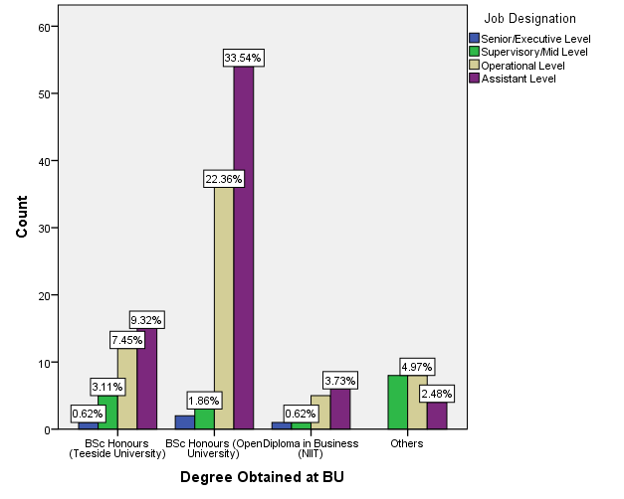
Figure 1: Job designation * Degree programme
Figure 1 shows that across programmes, most graduates (49.8%) were employed at assistant level than at any other level. Other levels of employment across programmes showed that 38.5% of the graduates were employed at operational level, 10.6% at supervisory level, and 1.1% at executive level. Programme-wise, most of the students employed at both assistant and operational levels than at other senior positions were from the BSc (Hons) Open University (55.9%) followed by the BSc (Hons) Teesside University with 20.5%. This is contrary to the findings of Brousseau and Driver (2010) who discovered that what satisfies employees in an organisation is career development (the linear career concept) which means an upward movement pattern of an employee which is the obvious and only acceptable measure of career success.

The institution’s graduate employment and field of specialisation

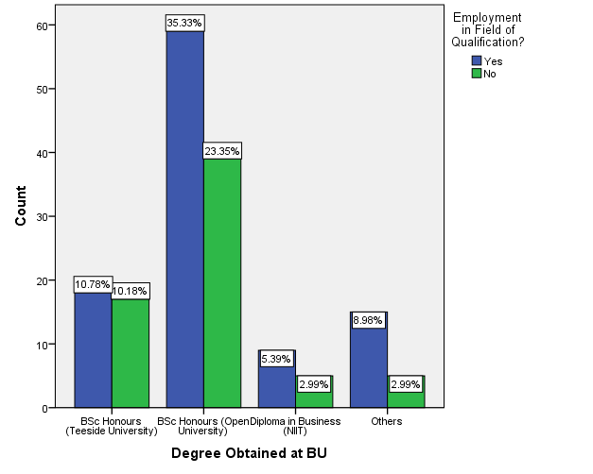
Figure 2: Employed in the field of specialisation * Degree programme
Figure 2 shows that across all programmes, most of the graduates of the selected institution (60.5%) agreed that they were employed in the field of specialisation with only 39.5% disagreeing. Of the graduates employed in the fields of specialisation, 35.3% came from BSc (Hons) Open University, 10.8% from BSc (Hons) Teesside, 9% from others, and 5.4% from Diploma in Business.
Figure 3 shows that across cohorts, most of the graduates (59.8%) were employed in their areas of specialisation while 40.2% were not. Of those employed in their areas of specialisation, most of the graduates came from the 2010 cohort (28.3%) followed by the 2012 cohort (13.9%). The least number of those employed in areas of specialisation came from the 2014 cohort. Having employees working in their areas of specialisation is a positive development for one’s career. This view is supported by Brousseau and Driver (2010) who aver that, according to the expert career concept, career advancement means advancing one's expertise in one's chosen discipline or field of work. They further postulate that career success, and hence satisfaction, is not about how many people one supervises, or the size of one's office, or the number of executive perks one enjoys, or even the size of one's pay check, but is a function of the level of technical expertise one has achieved. This is what the graduates of the selected HE institution were doing.
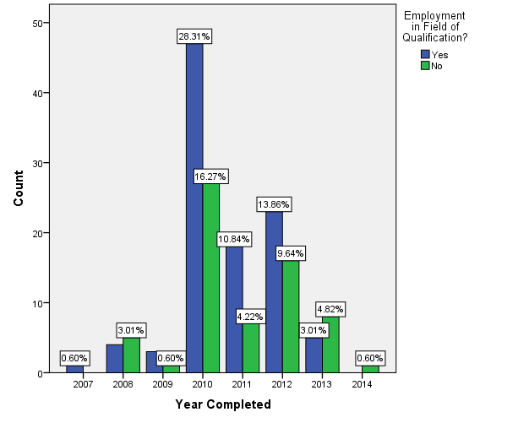
Figure 3: Employed in the field of specialisation across cohorts

Institution’s graduate contentment with current employment
Figure 4 shows that across gender, most graduates (79.5%) were not contented with their current employment while only 20.5% showed contentment. Out of those who did not show contentment, 47.1% were female graduates and 32.4% were male graduates. More female graduates (12.9%) also were not contented with their employment then when compared to 7.7% of male graduates.
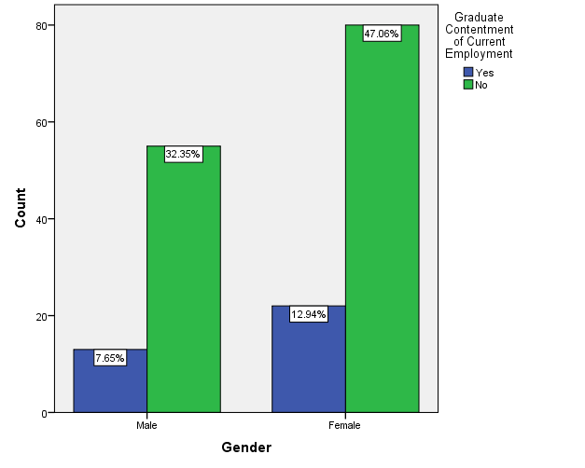

Figure 4: Graduate contentment with current employment * Gender
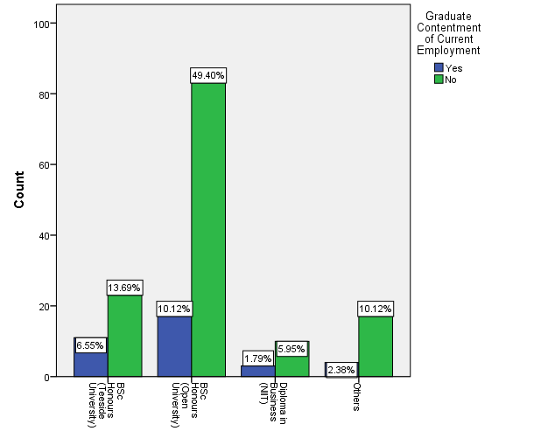
Figure 5: Graduate contentment with current employment * Degree programme
Figure 5 shows that most of the selected institution’s graduates (79.2%) across degree programmes, were not contented with their employment then while 20.8% were contended. Of those who did not show contentment, most of them (49.4%) came from the BSc (Hons) Open University while the least number (6%) came from Diploma in Business. The reason for this big difference between the preferences of diploma and degree graduates was that the diploma graduates were probably satisfied with the entry and operational levels of their careers while the degree graduates were dissatisfied possibly because they were expecting more senior and higher level positions and job responsibilities.
The institution’s graduates and relevance of training
This section presents findings on the views of graduates on the relevance of training they received from their institution.
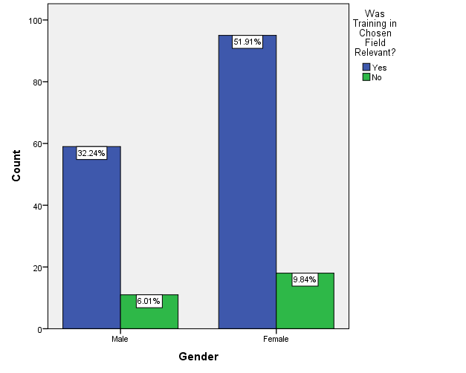
Figure 6: Relevance of training * Gender
Figure 6 shows that across gender most of the selected institution’s graduates (84.2%) indicated that the training they received during their schooling years was relevant to the field of employment they wanted to pursue while only 15.8 %) felt that the training they received was not relevant. There were more female graduates (51.9%) who indicated that their training was relevant when compared to male graduates (32.3%). Also more female graduates (9.8%) indicated that their training was not relevant when compared to male graduates (6%).
Figure 7 shows that across programmes, most graduates of the selected HE institution (84.5%) believed that the training they received was relevant to the kinds of employment they wanted to pursue. Of the graduates who believed that they received relevant training, 50.8% were from the BSc (Hons) Open University, 14.4% from BSc (Hons) Teesside University, 13.8% from others and 5.5% from Diploma in Business. That the majority of the graduates were employed in jobs that were relevant to their training could mean they were satisfied with this aspect of their careers. This view is supported by Brousseau and Driver (2010) who argue that according to the expert career concept, success results from finding a type of work that represents one's "calling" and (and work that represents one’s calling is one that a person trained in out of interest) then progressively becoming more and more skilled and competent in performing this work.
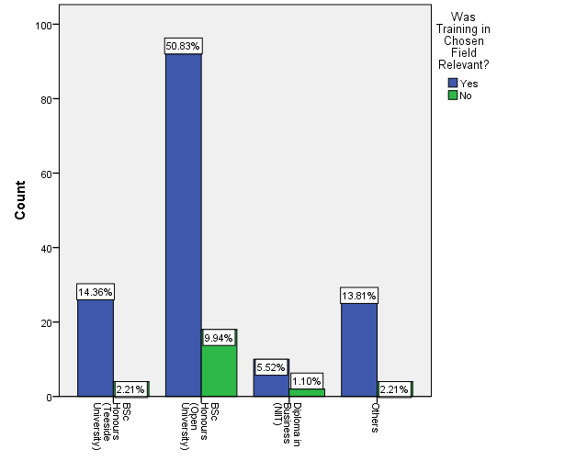
Figure 7: Relevance of training * Degree programme

Institution’s graduates’ intention to stay at current jobs
Figure 8 shows that across gender most of the selected institution’s graduates (64.6%) did not intend to stay at their current jobs while 35.4% indicated that they would stay. Of those who indicated that they would not stay, 41.5% were female graduates while 23.1% were male graduates. Of those graduates who indicated that they would stay, (20.4%) were female while 15% were male.
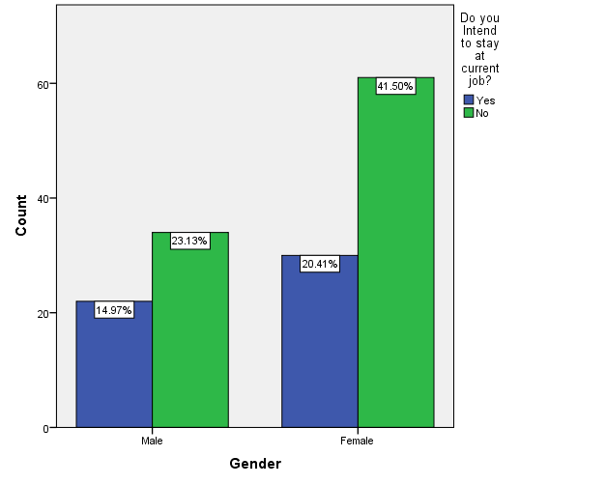
Figure 8: Intention to stay at current job * Gender

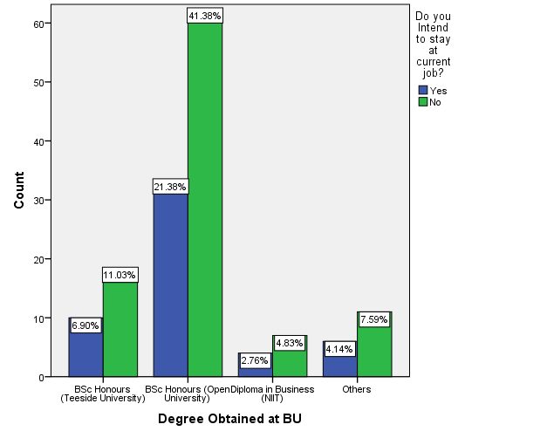
Figure 9: Intention to stay at current job per programme
Figure 9 shows that across programmes, most of the selected institution’s (76.5%) showed no intention to stay at their current jobs while only 23.5% showed that they were willing to stay at their current jobs for some time. Of those not willing to stay, most of the graduates were from the BSc (Hons) Open University (41.4%) with the least being from Diploma in Business (4.8%). This implied that the institution’s graduates were generally not satisfied with their jobs. According to http://www.job-interview-site.com), a job that satisfies employees is one that ensures the skills of the employee are utilised to the maximum and that also allows the same employee to rise up the ladder within the organisation. It is also a job with a work environment that allows employees to grow their positions and give them learning opportunities. This view is buttressed by Brousseau and Driver (2010) who postulate that the linear career concept denotes career success that revolves entirely around making upward progress within one’s career which is determined by how high one rises in a hierarchy where successively higher positions involve successively increasing levels of responsibility and authority.

CONCLUSION
This study revealed that the level of job satisfaction of the selected HE institution’s graduates was generally low based on recorded measures of employment satisfaction. In terms of job designation, across degree programmes and gender, the majority of the institution’s graduates were found at the lower rungs of the organisations they worked for, that is, at the assistant and operational levels with insignificant numbers at managerial level. Across degree programmes and different intakes, the results of the study indicated a positive scenario where the majority of the graduates were found to be employed in their areas of career specialisation, that is, in Information Technology (IT), especially those from 2013 and above. This was presumably because the programmes they studied had now established themselves among employers compared to the earlier cohorts who graduated in 2010, 2011, and 2012. This was indicative of career success and possibly job satisfaction in this area. However, a large number of the graduates indicated discontentment with their employment. This was found to be common across gender and degree programmes, that is, both UO and Teesside University. This was possibly due to the fact that the majority of these graduates were employed at the assistant and operational levels where salaries were lower and job responsibilities more routine. Therefore, their job did not provide an opportunity to learn, progress and contribute to the organisation; their work environment did not constitute a teamwork-oriented environment that empowers employees to create and take initiatives; the job did not ensure the skills of the employee were utilised to the maximum and allowed him/her to grow within the organization, and the job was not one where the employee could use his/her creative abilities to support, aid and mentor other professionals. These, among others, could have been the sources of discontentment.
The findings of the study revealed that across gender and degree programmes, the majority of BU graduates indicated that the training they received during their schooling years was relevant to the field of employment they were pursuing which is indicative of satisfaction with the relevance of their education. However, there was a general perception among the majority of the institution’s graduates across degree programmes and gender of having no intention to remain in the jobs they were doing for long. Again, the reasons for this were probably the limited upward movement of graduates along their careers meaning that the jobs lacked professional progress as well as creative satisfaction.

REFERENCES
Abu-Bakar, M.Y., Jani R. and Zubairi, Y. Z. (2009), “An overview of Graduate Employability of recent Graduates: Some Facts and Figures”, Seminar on Employability, The Ministry of Higher Education of Malaysia.

Arthur, M.B., Hall, D.T, and Barbara, S. (2013) Handbook of Career Theory, Cambridge University Press.
Brousseau, K.R. and Driver, M.J. (2010) CareerView: Roadmaps for Career Success - A Personal Manual for Career Insight, Decision Dynamics LLC
Driver, M .J. (2010), “Career Concepts and Organizational Change” in C. B. Derr (Ed.), Work, Family and the Career, New York, Praeger.
Driver, M. J. (2011), Career concepts: A new approach to career research” In R. Katz H. (Ed) Career issues in Human Resource Management Englewood Cliffs, NJ: Prentice-hall, 23-32.
Gines, A.C. (2014) “Tracer Study of PNU Graduates”, American International Journal of Contemporary Research, Vol. 4 No. 3.
Osipow, S. H. (2009), Manual for the Career Decision Scale (2nd ed.), Columbus, OH: Marathon Consulting and Press.
Patz, A.L., Milliman, J.F. and Driver, M.J. (2009) “Career concepts and total enterprise simulation performance”, Development in business simulation and experiential exercises, Vol 18, no. 1, pp. 84-89.
Powell, M. & Short, P (2013). A Consultation Paper providing a review and background of the national Internship Programme. Retrieved from www.bota.org.bw/.../THE%20NATIONAL%20INTERNSHIP%20PROG... [Accessed: 22 February 2016].
Schomburg, H. (2011) Handbook for Graduate Tracer Studies: Centre for Research on Higher Education and Work, University of Kassel, Germany.
Ugwuonah, G.E. and Omeje K.C. (2008) Final Report of Tracer Study Research Project on Higher Education and Work, Institute for Development Studies, University of Nigeria, Enugu Campus.

